Fishery Data Series No. YY-XX

Movement Patterns of Northern Pike in Alexander Lake

by

Dave Rutz

Kristine Dunker

Parker Bradley

Cody Jacobson

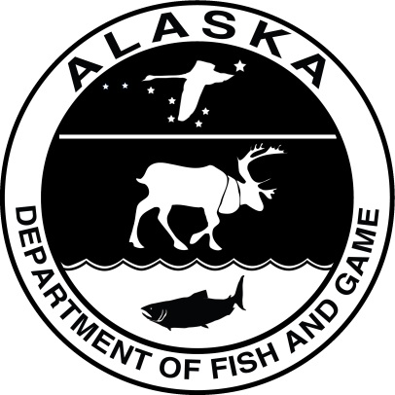

Month year

Alaska Department of Fish and Game Divisions of Sport Fish and Commercial Fisheries

Symbols and Abbreviations

The following symbols and abbreviations, and others approved for the Système International d'Unités (SI), are used without definition in the following reports by the Divisions of Sport Fish and of Commercial Fisheries: Fishery Manuscripts, Fishery Data Series Reports, Fishery Management Reports, and Special Publications. All others, including deviations from definitions listed below, are noted in the text at first mention, as well as in the titles or footnotes of tables, and in figure or figure captions.

**Weights and measures (metric)**

centimeter cm

deciliter dL

gram g

hectare ha

kilogram kg

kilometer km

liter L

meter m

milliliter mL

millimeter mm

**Weights and measures (English)**

cubic feet per second ft3/s

foot ft

gallon gal

inch in

mile mi

nautical mile nmi

ounce oz

pound lb

quart qt

yard yd

**Time and temperature**

day d

degrees Celsius °C

degrees Fahrenheit °F

degrees kelvin K

hour h

minute min

second s

**Physics and chemistry**

all atomic symbols

alternating current AC

ampere A

calorie cal

direct current DC

hertz Hz

horsepower hp

hydrogen ion activity pH

(negative log of)

parts per million ppm

parts per thousand ppt,

‰

volts V

watts W

**General**

Alaska Administrative

Code AAC

all commonly accepted

abbreviations e.g., Mr., Mrs., AM, PM, etc.

all commonly accepted

professional titles e.g., Dr., Ph.D.,

R.N., etc.

at @

compass directions:

east E

north N

south S

west W

copyright ©

corporate suffixes:

Company Co.

Corporation Corp.

Incorporated Inc.

Limited Ltd.

District of Columbia D.C.

et alii (and others) et al.

et cetera (and so forth) etc.

exempli gratia

(for example) e.g.

Federal Information

Code FIC

id est (that is) i.e.

latitude or longitude lat or long

monetary symbols

(U.S.) $, ¢

months (tables and

figures): first three

letters Jan,...,Dec

registered trademark ®

trademark ™

United States

(adjective) U.S.

United States of

America (noun) USA

U.S.C. United States Code

U.S. state use two-letter abbreviations (e.g., AK, WA)

**Mathematics, statistics**

*all standard mathematical*

*signs, symbols and*

*abbreviations*

alternate hypothesis HA

base of natural logarithm *e*

catch per unit effort CPUE

coefficient of variation CV

common test statistics (F, t, χ2, etc.)

confidence interval CI

correlation coefficient

(multiple) R

correlation coefficient

(simple) r

covariance cov

degree (angular ) °

degrees of freedom df

expected value *E*

greater than >

greater than or equal to ≥

harvest per unit effort HPUE

less than <

less than or equal to ≤

logarithm (natural) ln

logarithm (base 10) log

logarithm (specify base) log2, etc.

minute (angular) '

not significant NS

null hypothesis HO

percent %

probability P

probability of a type I error

(rejection of the null

hypothesis when true) α

probability of a type II error

(acceptance of the null

hypothesis when false) β

second (angular) "

standard deviation SD

standard error SE

variance

population Var

sample var

fishery Data Series report no. YY-XX

Movement Patterns of Northern PIke in Alexander Lake

by

Dave Rutz, Kristine Dunker, Parker Bradley, and Cody Jacobson

This investigation was partially financed by an Alaska Sustainable Salmon Grant administered through NOAA under grants 4965 and 4910 along with a General Fund Match from the Alaska State Legislature.

Alaska Department of Fish and Game  
Division of Sport Fish, Research and Technical Services  
333 Raspberry Road, Anchorage, Alaska, 99518-1565

Month Year

ADF&G Fishery Data Series was established in 1987 for the publication of Division of Sport Fish technically oriented results for a single project or group of closely related projects, and in 2004 became a joint divisional series with the Division of Commercial Fisheries. Fishery Data Series reports are intended for fishery and other technical professionals and are available through the Alaska State Library and on the Internet: <http://www.adfg.alaska.gov/sf/publications/>. This publication has undergone editorial and peer review.

Dave S. Rutz,

Alaska Department of Fish and Game, Division of Sport Fish,

1800 Glenn Highway, Suite 2, Palmer AK 99645-6736, USA (Retired)

Kristine Dunker

Alaska Department of Fish and Game, Division of Sport Fish,

333 Raspberry Road, Anchorage AK 99518-1599, USA

Parker Bradley

Alaska Department of Fish and Game, Division of Sport Fish,

1800 Glenn Highway, Suite 2, Palmer AK 99645-6736, USA

Cody Jacobson

Alaska Department of Fish and Game, Division of Sport Fish,

1800 Glenn Highway, Suite 2, Palmer AK 99645-6736, USA

This document should be cited as follows:

Rutz, D., K. Dunker, P. Bradley and C. Jacobson. 2018. Movement Patterns of Northern Pike in Alexander Lake. Alaska Department of Fish and Game, Fishery Data Series Report No. YY-XX, Anchorage.

The Alaska Department of Fish and Game (ADF&G) administers all programs and activities free from discrimination based on race, color, national origin, age, sex, religion, marital status, pregnancy, parenthood, or disability. The department administers all programs and activities in compliance with Title VI of the Civil Rights Act of 1964, Section 504 of the Rehabilitation Act of 1973, Title II of the Americans with Disabilities Act (ADA) of 1990, the Age Discrimination Act of 1975, and Title IX of the Education Amendments of 1972.

**If you believe you have been discriminated against in any program, activity, or facility please write:**

ADF&G ADA Coordinator, P.O. Box 115526, Juneau, AK 99811-5526

U.S. Fish and Wildlife Service, 4401 N. Fairfax Drive, MS 2042, Arlington, VA 22203

Office of Equal Opportunity, U.S. Department of the Interior, 1849 C Street NW MS 5230, Washington DC 20240

**The department’s ADA Coordinator can be reached via phone at the following numbers:**

(VOICE) 907-465-6077, (Statewide Telecommunication Device for the Deaf) 1-800-478-3648,

(Juneau TDD) 907-465-3646, or (FAX) 907-465-6078

**For information on alternative formats and questions on this publication, please contact:**

ADF&G Division of Sport Fish, Research and Technical Services, 333 Raspberry Road, Anchorage AK 99518 (907) 267-2375

TABLE OF CONTENTS

Page

LIST OF TABLES i

LIST OF FIGURES i

LIST OF APPENDICES i

Abstract 3

Introduction 3

Synopsis 3

Background 3

Need 6

Methods 6

study area 6

Objectives 6

Objectives 7

Study Design 7

Overview 7

Methods: Radio Telemetry Assessment of Northern Pike Movements in Alexander Creek (*Objective 1*) 7

Methods: Assessment of juvenile and age-1 northern pike emigrating from Alexander Lake into the Creek (*Objective 2*). 10

Results 10

Radio Telemetry Assessment of Northern Pike Movements in Alexander Creek (*Objective 1*) 10

Assessment Juvenile and age-1 Northern Pike Emigrating from Alexander Lake into the Creek (Objective 2). 13

DISCUSSION & Recommendations 14

Discussion 14

Recommendations 16

ACKNOWLEDGMENts 16

REFERENCES cited 18

Appendices 20

# LIST OF TABLES

Table Page

**No table of figures entries found.**

# LIST OF FIGURES

Figure Page

**No table of figures entries found.**

# LIST OF APPENDICES

Appendix Page

Appendix A. Alexander Creek drainage northern pike radio-tag deployment, July 2011. 20

Appendix B1. Movements of lake-tagged northern pike #33 (151.823-8) in Alexander Creek drainage, September 2011 through June 2013. 23

Appendix B2. Movements of lake-tagged northern pike #143 (151.902-19) in the Alexander Creek drainage, June 2012 through early June 2013. 24

Appendix B3. Movements of lake-tagged northern pike #28 (151.823-2) in the Alexander Creek drainage, August 2011 through May 2012. 25

Appendix B4. Movements of lake-tagged northern pike #301(151.823-4) in the Alexander Creek drainage, August 2011 through May 2012. 26

Appendix B5. Movements of lake-tagged northern pike #32 (151.823-6) in the Alexander Creek drainage, September 2011 through May 2012. 27

Appendix B6. Movements of lake-tagged northern pike #39 (151.823-15) in the Alexander Creek drainage, Sept 2011 through May 2012. 28

Appendix B7. Movements of lake-tagged northern pike #129 (151.902-3) in the Alexander Creek drainage, August 2011 through May 2012. 29

Appendix B8. Movements of lake-tagged northern pike #97 (151.862-23) in the Alexander Creek drainage, August 2011 through June 2013. 30

Appendix B9. Movements of lake-tagged northern pike #92 (151.862-19) in the Alexander Creek drainage, August 2011 through June 2013. 31

Appendix B10.–Movements of lake-tagged northern pike #40 (151.823-16) in the Alexander Creek drainage, August 2011 through June 2013. 32

Appendix B11. Movements of lake-tagged northern pike #96 (151.862-22) in the Alexander Creek drainage, September 2011 through June 2013. 33

Appendix B12. Movements of lake-tagged northern pike #99 (151.862-26) in the Alexander Creek drainage, August 2011 through June 2013. 34

Appendix B13. Movements of lake-tagged northern pike #139 (151.902-14) in the Alexander Creek drainage, September 2011 through June 2013. 35

Appendix B14. Movements of lake-tagged northern pike #26 (151.823-0) in the Alexander Creek drainage, September 2011 through June 2013. 36

Appendix B15. Movements of lake-tagged northern pike #101 (151.882-0) in the Alexander Creek drainage, August 2011 through June 2013. 37

Appendix B16. Movements of creek-tagged northern pike #18 (151.802-19) in the Alexander Creek drainage, August 2011 through May 2013. 38

Appendix B17. Movements of creek-tagged northern pike #17 (151.802-06) in the Alexander Creek drainage, September 2011 through May 2012. 39

Appendix B18. Movements of creek-tagged northern pike #9 (151.802-09) in the Alexander Creek drainage, August 2011 through June 2013. 40

Appendix B19. Movements of creek-tagged northern pike #21 (151.802-22) in the Alexander Creek drainage, August 2011 through April 2012. 41

Appendix B20. Movements of creek-tagged northern pike #22 (151.802-23) in the Alexander Creek drainage, August 2011 through May 2012. 42

Appendix B21. Movements of lake-caught pike #23 (151.802-24), transferred, tagged and released in lower Alexander Creek, September 2011 through April 2012. 43

# Abstract

In 2011, the Alaska Department of Fish and Game (ADF&G) began a long-term invasive northern pike *Esox lucius* suppression program in side-channel sloughs of Alexander Creek. To determine if Alexander Lake, at the headwaters of this system, served as a significant source of pike to Alexander Creek or other adjacent watersheds, a northern pike movement study was conducted on Alexander Lake between 2011 and 2014 using radio-telemetry. A total of 125 mature northern pike were captured in Alexander Lake and 25 in Alexander Creek and surgically implanted with radio transmitter tags. During this study, few radio-tagged pike migrated into the creek, and no radio-tagged pike left the system. All pike that left the lake were later captured downstream in gillnets by pike suppression crews and dispatched. The telemetry project indicated that pike movements out of Alexander Lake were not detrimental to ADF&G’s suppression efforts. Between 2014 and 2016, ADF&G attempted to investigate if juvenile northern pike movement patterns differed from those observed for mature northern pike, but this question could not be answered because juvenile pike did not recruit to sampling gear.

Key words: Northern pike, radio telemetry, radio tags, seasonal movements, migration, seasonal distributions, Susitna River drainage, invasive species

# Introduction

## Synopsis

The northern pike *Esox lucius* is a predatory fish that is invasive to Southcentral Alaska and is responsible for the loss of several fisheries across the region. Alexander Creek in the Susitna River basin is one of the most heavily impacted systems (Rutz and Yanusz 2008). The Alaska Department of Fish and Game (ADF&G) has been annually suppressing the invasive northern pike population since 2011 (Rutz et al. 2019). The primary goal of pike suppression in Alexander Creek is to restore the quality of salmon rearing habitat by annually reducing the number of mature northern pike in the backwater sloughs of the creek. However, there is a prolific population of northern pike in Alexander Lake at the headwaters of the creek. For this study, we investigated movement patterns of northern pike between Alexander Lake and Alexander Creek to assess whether the strategy of focusing suppression efforts in side-channel sloughs of the creek could be effective, or whether movement of pike out of Alexander Lake would impede suppression success.

## Background

Invasive northern pike pose a significant threat to salmon habitats in Southcentral Alaska (ADF&G 2007). Northern pike are native throughout much of the state but do not naturally occur south and east of the Alaska Range (Figure 1). It is thought that northern pike were first introduced by an air charter operator to the Yentna River drainage (Bulchitna Lake, Lake Creek drainage) in the late 1950’s and, from there, subsequently spread throughout the Susitna River basin via natural migration and further illegal stockings. Based on reports from local residents, northern pike are believed to have been illegally introduced to Alexander Lake in the late 1960s, although there was no harvest record of them prior to 1985 (Mills 1986).

Anecdotal accounts from Alexander Creek area residents suggest that dispersal of northern pike from the lake to the lower river occurred slowly over a 30-year period. The first documented catch of northern pike in the lower Alexander Creek drainage (RM 0-1) was in the mid-1990s. Today, northern pike are widespread throughout the system. The majority of the drainage is shallow, low velocity, meandering, with numerous side-slough channels, interconnecting shallow lakes and ponds, tens of thousands of acres of adjacent wetland areas and dense aquatic instream vegetated areas, making it ideal northern pike habitat (Morrow 1980, Inskip 1982).

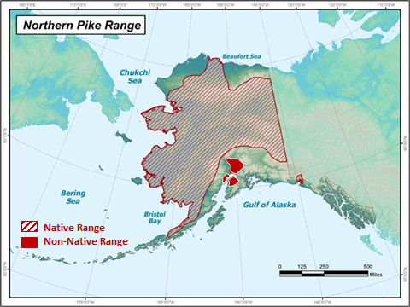

Figure 1. Distribution of native and non-native northern pike in Alaska.

Prior to 2000, Alexander Creek was one of the most productive Chinook salmon *Oncorhynchus tshawytscha* systems in the entire Northern Cook Inlet (NCI) area. During its productive years, this system experienced an average of 13,700 angler days (Oslund et. al. 2015). During that same period, the Chinook salmon fishery contributed greater than 90% of the sport fishing effort, and an average of 2,880 Chinook salmon were harvested annually (Ivey et al. 2007). Since the late 1990s, northern pike have reduced the populations of multiple fish species in the Alexander Creek drainage including Chinook salmon which last achieved escapement in 2005. This culminated in the Alaska Board of Fisheries designating Alexander Creek’s Chinook salmon as a Stock of Concern in 2011. Because of poor returns, the Chinook sport fishery has been closed to harvest since 2008. Aerial surveys have been flown on Alexander Creek annually since 1979 and have shown a distinct change in Chinook salmon spawner distribution patterns. Since 1992, Chinook salmon spawners disappeared from the tributaries upstream of Alexander Lake, and, since about 1998, also from much of the mainstem of Alexander Creek (i.e. both upstream and downstream of the Sucker Creek confluence; Figure 2). In addition, harvest of coho *Oncorhynchus kisutch* salmon has been below the historical average since 2004, and the once popular and abundant rainbow trout *Oncorhynchus mykiss* and Arctic grayling *Thymallus arcticus* fisheries were also closed to harvest in 1996 (Whitmore and Sweet 1998). Despite these fisheries becoming catch-and-release, catch rates have declined over the past 20 years for both species (Oslund et al. 2017). Northern pike establishment in Alexander Creek is believed to be the primary factor resulting in these declines.

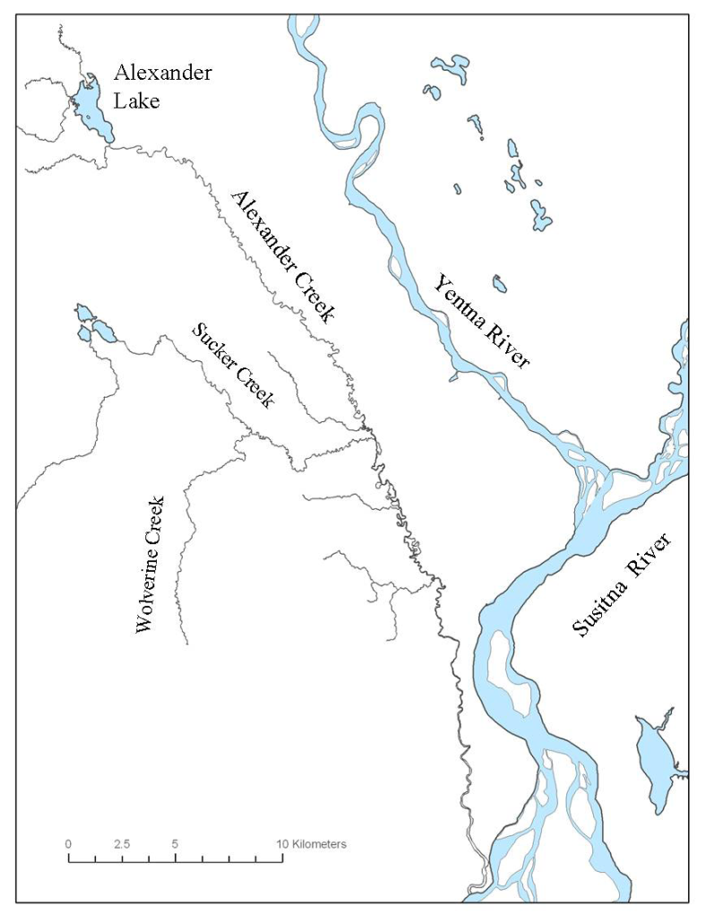

Figure 2. Map of the Alexander Creek drainage

## Need

The mission of ADF&G’s Sport Fish Division is “to protect and improve the state’s recreational fisheries resources”, and a crucial objective of the Division’s strategic plan is to “minimize impacts of invasive species on fish stocks, recreational fisheries, and fish habitat”. To reduce northern pike abundance and increase salmonid productivity and sport fishing opportunities within the Alexander Creek drainage, a long-term northern pike suppression program was initiated in 2011 (Rutz et al. 2019). Crews intensively gillnet side-channel sloughs of Alexander Creek on an annual basis during the northern pike spawning period. One critical question is whether this strategy of focusing suppression in Alexander Creek sloughs can be effective without pike suppression in Alexander Lake, which would be a much more expensive endeavor. To address this question, a northern pike movement study was conducted between 2011 and 2014 using radio telemetry to identify movement patterns of northern pike throughout the Alexander Creek drainage.

# Methods

## study area

Alexander Lake is an approximately 356-hectare shallow lake with a mean depth of about 1.2 meters. It is vegetated throughout and is the headwaters to Alexander Creek which flows into the west side of the Susitna River approximately eight river miles upstream from where the Susitna River drains into Cook Inlet. The creek’s length is approximately 66 km from its headwaters at the lake to its confluence with the Susitna River (Figure 2). Alexander Creek’s mainstem can be characterized as a tannin stained, low gradient, slow velocity, meandering channel with a large portion of the river comprising dense vegetative mats. This drainage encompasses hundreds of square miles and is comprised of interconnecting shallow lakes and ponds, vast expanses of adjacent wetlands and marshes, and numerous backwater side-sloughs and oxbow-channels which are typically shallow stagnant waters with low flows containing dense aquatic vegetation, all of which provide optimum spawning and rearing habitat for pike. Northern pike are well suited to this type of system (Inskip 1982, Rutz 1996), and are currently well distributed throughout.

## Objectives

The ultimate goal of Alexander Creek pike suppression is to restore anadromous and resident fish populations by increasing their productivity and, secondly, to restore sport fishing opportunities. To determine if this could even be possible with planned pike suppression strategies, a northern pike movement study was conducted between Alexander Lake and Alexander Creek. Past Susitna River drainage studies have documented radio-tagged northern pike moving within and between drainages in the Susitna River (Rutz 1999). If significant movement of pike was found to occur between Alexander Lake and Alexander Creek, the strategy of focusing pike suppression activities in side-channel sloughs of Alexander Creek would likely be ineffective in increasing salmonid survival because recruitment of pike from Alexander Lake could replace pike removed in gillnets in the creek. Should this be the case focused pike suppression in Alexander Lake would then be necessary but is far more logistically complex and cost-prohibitive.

Specific objectives for this study are as follows:

### Objectives

1. Estimate the proportion of radio-tagged northern pike residing in Alexander Lake that migrate at least once to Alexander Creek from July 15, 2011 – June 30, 2014 such that the estimated proportion is within 15 percentage points of the true value 95% of the time.
2. Calculate the catch per unit effort (CPUE) of young of the year and 1-year-old northern pike captured in fyke nets downstream of the outlet of Alexander Lake and estimate the proportion of this catch that migrates to Alexander Creek sloughs between May 7, 2014 – September 30, 2016.

## Study Design

### Overview

As stated, the primary goal of annual pike suppression in Alexander Creek is to increase salmonid productivity and restore fisheries in the drainage by suppressing the invasive northern pike population. Given the size and complexity of the Alexander system, complete eradication of northern pike would be extremely costly and logistically-prohibitive and, thus, not likely a viable option. However, relieving some of the predation pressure on salmon fry, fingerling and smolt has potential to increase their abundance by contributing to greater survival (Muhlfeld et al. 2008, Sepulveda 2015). Over time, it is expected that greater survival of juvenile salmon may result in larger annual returns of these species and other resident fish populations. Eventually, ADF&G hopes to restore salmon and resident fish production to levels similar to those observed during the 1990s when viable fisheries co-existed with a less abundant northern pike population that existed during that time in Alexander Creek (Whitmore and Sweet 1998).

Current pike management in the system involves gillnetting up to 69 slough channels located adjacent to the mainstem of Alexander Creek. Operations commence in early to mid-May and continue through early June during the spring spawning period when northern pike are the most mobile and concentrated (Diana 1977, Rutz 1996).

To assess whether this strategy could be effective, ADF&G investigated movement patterns of northern pike in the Alexander Creek drainage. This study was also one of the first comprehensive investigations of northern pike movement patterns within an open system outside of its native range in Alaska. Northern pike movements have been described in areas of the state where northern pike naturally occur (Taube and Lubinski 1996, Roach 1998, Chythlook and Burr 2002). Beside anecdotal information from floy tag recoveries or small scale studies of pike movement in the Susitna River drainage (Rutz 1996 1999), little information is available describing distribution and movement patterns of Alaska’s invasive northern pike populations, in particular the invasive population in the Alexander system, Results from this study could help inform future northern pike control efforts or eradication projects.

### Methods: Radio Telemetry Assessment of Northern Pike Movements in Alexander Creek (*Objective 1*)

Spatial and temporal movement patterns of invasive northern pike in the Alexander Creek drainage were assessed through radio telemetry techniques with the main emphasis on estimating the number of radio-tagged pike in Alexander Lake that emigrated into the creek or other adjacent waters. During July of 2011, 150 northern pike, greater than 440 mm in fork length, were surgically implanted with F1845 Advanced Telemetry Systems (ATS) radio transmitters using standard surgical procedures (Ross and Kleiner 1982, Summerfelt and Smith 1990). Radio transmitters were 42 mm in length, 17 mm in diameter, and weighed about 14 g with a 30-cm external whip antenna and a battery capacity of approximately 693 days (1.9 years). In addition, each of the radioed pike were tagged with a sequentially numbered T-bar floy tag. A total of 125 fish were captured and radio-tagged in the lake while 25 were captured and radio tagged in the creek (Appendix A). All northern pike that were tagged were captured using hook and line. After tags were surgically implanted, the fish were measured, and then held in an aerated recovery tank until they recuperated enough to be released back to their original capture location. The 125 northern pike captured in the lake were collected throughout the lake’s entirety. Pike captured in the creek were either captured near the outlet of Alexander Lake (RM 40) or near the creek’s confluence with the Susitna River (RM 1-3). Average surgery time was approximately five minutes per fish. All fish were released in good health and were active prior to their release.

Radio-tagged northern pike were tracked monthly from July of 2011 through June of 2013 for a total of 24 tracking flights. It was expected that approximately half of radio-tagged northern pike would survive the entire two-year study (Taube and Lubinski 1996, Roach 1998). Detailed records of the tag numbers and movement distances were kept and monitored for all tagged pike. There were six separate frequencies used for the 150 radio tags implanted in the pike. All frequencies were within the 150.000 - 151.999 MHz range. Efforts were made to ensure the frequencies used did not conflict with any other ongoing radio telemetry studies. Each frequency had 25 different transmission patterns (“pulse codes”), resulting in 150 uniquely identifiable transmitters (radio tags). Because northern pike can remain sedentary for long periods of time, the transmitters included mortality indicators. Movements of radio tagged fish were monitored through a combination of repeated aerial surveys and three tracking stationary receiving towers.

A single engine, Piper PA-12, fixed wing aircraft was used for aerial surveys. Aerial telemetry surveys were conducted to detect general distribution and major northern pike movements. During aerial surveys, a Yagi antenna was mounted on each wing strut with the antenna oriented forward and slightly downward with the elements vertical to maximize the reception. Both antennas were connected by antenna cable which was then attached to the receivers. Two ATS Model 4500 radio receivers with internal GPS receivers were programmed to continuously scan all frequencies and create a log of the tags detected and their latitude and longitude. Flight tracking surveys were scheduled to take place monthly between September and March, twice in April, weekly during May, and twice a month between June and August. Actual surveys flown were dependent on weather and pilot availability.

Stationary receivers were installed at the mouth of Alexander Lake (RM 40), near the confluence of Alexander Creek and Sucker Creek (RM 23), and approximately three miles upstream of the confluence of Alexander Creek (RM 3) with the Susitna River (Figure 3). Tracking stations consisted of an ATS 4500 receiver and self-contained power system. Radio-tagged fish within reception range of the stations were identified and recorded. Information collected included the date and time the fish was present at the site, the signal strength, and the location of the fish (upstream or downstream of the tower) in relation to the station. Information on tracking station operations (i.e., voltage levels for the station components and whether the reference transmitter at the site was properly recording) was also documented. A field crew traveled to each of the three stationary receivers once a month during the open water season to manually download data from early May through September. Receivers were pulled from their tower location generally from October through early May of each year to avoid freezing and breakage of crystalline data display boards in the receivers.

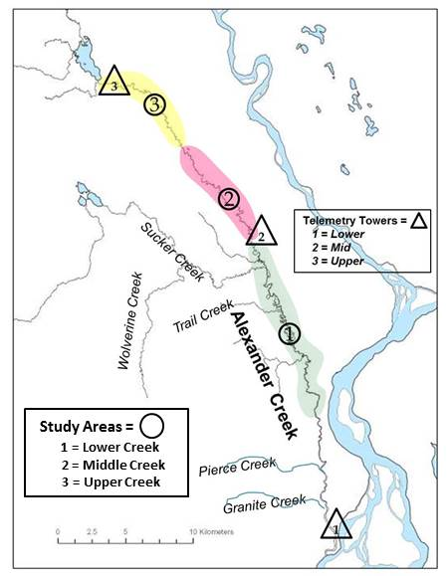

Figure 3. Map of the Alexander Creek drainage, tributaries, study reaches and radio telemetry tower locations.

The proportion of northern pike leaving Alexander Lake was estimated to address the question of whether northern pike migrate from the lake into the creek or into other drainage systems. The proportion of northern pike leaving Alexander Lake was estimated as:

where: $\hat{p}=\frac{s_{t}}{n}$

 $s_{t}$ $s_{t}$ = the number or radio tags detected leaving Alexander Lake

 $n$ = the total number of radio tags originally deployed in the lake and

 $\hat{p}$ = the proportion of northern pike leaving the lake.

For those pike that exited the lake, the maximum downstream distance of each fish was measured to the nearest km to document the spatial extent of these movements. Graphically, the movements of all radio-tagged pike were mapped in ArcMap 10.2 to illustrate the maximum extent of the movements observed and to visually represent any seasonal movement patterns (Appendices B1-B21).

### Methods: Assessment of juvenile northern pike emigrating from Alexander Lake into the Creek (*Objective 2*).

To qualitatively investigate if juvenile pike were emigrating from the lake into the creek, two fyke nets were installed adjacent to each bank of the outlet of Alexander Lake with the cod ends facing in the downstream position and the open end (catch end) facing upstream. The modified fyke nets measured .9 m by 1.5 m long with 6 mm square mesh nylon netting on 5 3-m aluminum hoops with finger-style throats on the second and third hoops and with attached 4 m leads. Fyke nets were fished from 20 May through 20 June in 2014, from 19 May through 30 June in 2015, and from 15 May through 10 September during 2016. Nets were checked daily when field crews were present and opportunistically thereafter.

# Results

### Radio Telemetry Assessment of Northern Pike Movements in Alexander Creek (*Objective 1*)

A total of 150 northern pike were captured and surgically implanted with radio tags between 6 July and 26 July 2011 (Appendix A). All pike that were tagged were transmitting live signals and in good condition at the time of their release. Tagged pike ranged in length from 440 mm to 786 mm. Of the 150 tagged pike, 125 were tagged in the lake and 25 in the creek. Of the tagged pike that left the lake, no movements were observed or documented through either areal tracking or locates from stationary receivers until April of 2012. Only eight of the 125 radio-tagged pike exited the lake, and all eight did so between mid-April and early May (Table 1). Given that spawning for Susitna Basin northern pike occurs during this time frame, those pike may have left the lake to spawn elsewhere in the system. Because all the radio-tagged pike that left the lake were captured in gillnets and dispatched, it is unknown whether they would have returned to the lake, resided in the creek, or migrated to another system. Movements of these fish from the lake occurred for both study years (2012-2013) prior to stationary towers being operational in the spring, so radio locates of these fish were based off aerial surveys alone.

Table 1. Capture habitat, frequency and tag number, location of recapture, and minimum distance traveled from the original tagged location for radio-tagged northern pike, 2011-2013.

|  |  |  |  |  |  |  |  |
| --- | --- | --- | --- | --- | --- | --- | --- |
| **Initial Capture Habitat** | **Fish #** | **Frequency - Tag Number** | **Tag Date** | **Recapture Date** | **Slough # (Recapture)** | **Capture Gear** | **Known Distance Traveled (km)** |
| Lake | 28 | 151.823-2 | 7/6/2011 | 5/9/2012 | 20 | Gillnet | 22.5 |
| Lake | 30 | 151.823-4 | 7/6/2011 | 5/14/2012 | 27 | Gillnet | 19.3 |
| Lake | 32 | 151.823-6 | 7/7/2011 | 5/27/2012 | 48 | Gillnet | 5.6 |
| Lake | 33 | 151.823-8 | 7/6/2011 | 5/31/2013 | 1 | Gillnet | 48.3 |
| Lake | 39 | 151.823-15 | 7/6/2011 | 5/9/2012 | 40.5 | Gillnet | 7.2 |
| Lake | 47 | 151.862-23 | 7/7/2011 | 6/2/2012 | 37 | Gillnet | 9.9 |
| Lake | 129 | 151.902-3 | 7/8/2011 | 6/11/2012 | 39 | Gillnet | 9.7 |
| Lake | 143 | 151.902-19 | 7/7/2011 | 6/13/2013 | 18 | Gillnet | 25.7 |
| Creek | 7 | 151.802-6 | 7/7/2011 | 5/29/2012 | 48 | Gillnet | 5.6 |
| Creek | 22 | 151.802-23 | 7/7/2011 | 5/18/2012 | 2 | Gillnet | 17.7 |

By May 2012, only 101 of the original 125 tags from the lake-tagged fish remained viable (continued to broadcast live signals). Of the original 125 lake-tagged fish, four were never located during any of the aerial tracking events or by the stationary towers. It’s assumed that either the radios malfunctioned, they were immediately caught by anglers and not reported, or they left the system before stationary receivers were operational. Fifteen of the fish displayed successive mortality signals, two were either captured and not reported by anglers or the radio transmitters eventually malfunctioned, and three were confirmed to have been caught by anglers (Table 2). During 2012, of the 101 lake-tagged fish remaining, six (5.9%) migrated from the lake into the creek. By May 2013, only 68 of the original 125 radio-tagged fish remained viable with 40 of the original tagged fish displaying mortality signals. Of the 68 remaining fish, only two (3%) left the lake. All radio-tagged pike that were documented exiting the lake were captured in gillnets downstream in the creek by ADF&G pike suppression crews, either in the spring of 2012 or 2013 (Table 2).

Table 2. Fate of Alexander Lake radio tagged northern pike, 2012 and 2013.



Of the fish that left the lake, the furthest known downstream distance from initial capture site was recorded for fish #33 (151.823-8; Table 1). This fish was captured, tagged, and released in northeast Alexander Lake. It mainly resided in the southern portion of the lake and then moved downstream a distance of approximately 48.3 km where it was captured by an ADF&G gillnet crew in the most downstream slough targeted on June 9, 2013 (Appendix B1). The second furthest downstream movement recorded was for lake-tagged fish #143 (151.902-19). This fish was tagged in northwest Alexander Lake and resided in close proximity to its original capture site prior to exiting the lake in the spring of 2013. It then traveled downstream a distance of 25.7 km before being captured by ADF&G crews in a slough in June 2013 (Appendix B2).

Pike #28 (151.823-2) was tagged in the northwest area of the lake and was located throughout the lake during most tracking events. In the spring of 2012 this fish left the lake and was captured by ADF&G gillnet crews in a slough, traveling a distance of 22.5 km from its original location of capture (Appendix B3). Pike #30 (151.823-4) was also captured and tagged in the northwest section of Alexander Lake; however, this fish had a more localized range, at least while residing in the lake, spending most of its time in the southernmost area of the lake and then exiting the lake in April or May 2012, traveling a distance of 19.3 km downstream prior to being captured by ADF&G gillnetting crews in May of 2012 (Appendix B4). The remaining four radio-tagged fish that left lake either displayed localized ranges or displayed a more widespread dispersal prior to exiting the lake (Appendices B5-B8). All four of these fish were recovered by ADF&G sampling crews in sloughs less than 10 km from the lake outlet. A radio signal form one additional lake-tagged fish (151.862-19) was received that would have located it approximately 20 km downstream; however, this fish was considered a mortality prior to leaving the lake, and all signals received downstream were mortality signals (Appendix B9).

Most (95%) of the northern pike that were tagged in the lake did not leave the lake. Habitual distribution of lake-residing pike demonstrated three distinct spatial patterns: localized (utilizing a specific area of the lake) or lake-wide distribution, but most of the lake-tagged pike demonstrated movement patterns somewhere in between the two. Examples of lake pike displaying more localized distribution patterns include pike #40 (151.823-16), #96 (151.862-22), and #99 (151.862-26), (Appendices B10-B12), while examples of pike showing lake-wide ranges are shown by pike #139 (151.902-14), #26 (151.823-0) and #101 (151.882-0) (Appendices B13-B15*)*.

Of the 25 northern pike that were radio tagged in the creek, ten (one of which was a lake-caught fish that was accidentally tagged and transported downstream and released) were tagged within three miles of the creek confluence with the Susitna River, and 15 were caught and tagged within 1 km of the outlet of Alexander Lake (Appendix A, Figure 2). Of the 25 northern pike that were radio-tagged in Alexander Creek, only six remained alive through the duration of the telemetry study; twelve succumbed to what we assumed to be natural mortality, five were either caught by anglers or subject to battery failure, and, finally, two were caught in gillnets by field sampling crews (Table 3). Of the 15 fish that were implanted with radio tags in the upper river (near the outlet of Alexander Lake), six survived the duration of the study, eight died from natural mortality during the study, and one either had radio battery failures or was caught by an angler. The pike that were tagged near the outlet of Alexander Lake generally migrated into the lake for most of the year, but not moving more than five or six km. The typical movement of upper creek-tagged fish is shown by fish# 18 (151.802-19; Appendix B16). Of the 10 fish radio-tagged in the lower river, two were caught in gillnets, four succumbed to natural mortality, four were either caught by anglers, the radio transmitter failed, or the fish left the system (Table 3).

Table 3. Fate of Alexander Creek radio-tagged northern pike that were captured, tagged and released in the upper and lower sections of the creek, 2011–2013.



The greatest known movement of a pike captured, tagged, and released in the lower creek was for fish #7 (151.802-6; Appendix B17). The last observed downstream location of this fish was on 13 May 2012 when it was located near river mile 12, approximately 17.7 km from its capture site; the next survey was flown on 27 May 2012, and that same fish was found nearly 42 km upstream of its previous location. Within a 14-day timespan, the total distance that particular fish moved from location of capture to its last tracked location was nearly 60 km. Three of the lower creek radio-tagged fish #9 (151.802-9), #21 (151.802-22), and #22 (151.802-23) generally moved throughout a 16 km reach of the lower river and appeared to migrate upstream to river mile 10, most likely to spawn given the timing of their migrations (Appendices B18-B20). Other lower creek-tagged fish generally moved less than 5 km from the location of their original tagging site.

Of note, one of the creek-tagged fish #23 (151.802-24) was actually caught in the lake on 26 July 2011 and was transported downstream, tagged, and released on that same day. The release location was lower Alexander Creek, approximately 3.2 km upstream of the confluence with the Susitna River. This fish migrated approximately 64 km back upstream and into the lake by 13 September 2011 and remained, for the most part, in the middle section of the lake for the duration of the study (Appendix B21).

### Assessment Juvenile Northern Pike Emigrating from Alexander Lake into the Creek (Objective 2).

Despite measures to capture juvenile northern pike from 2014 through 2016, no juvenile pike were observed by staff or captured in fyke nets which were strategically placed at the outlet of Alexander Lake, for all three study years (2014–2016).

# DISCUSSION & Recommendations

## Discussion

During this study, no major movement patterns of northern pike out of Alexander Lake into Alexander Creek or adjacent water bodies was observed. This was an important question with ramifications for the entire northern pike suppression strategy in this system. If this study would have shown a significant portion of the lake-tagged pike exited the lake to rear or spawn in the creek, suppression efforts would have needed to expand to include the lake, and this is both a costly and potentially controversial endeavor. Prior to this study, little information was available on the movement of Alexander Creek northern pike. Preliminary radio telemetry data from the 1990s demonstrated that northern pike can move more than 10 km within a year, and movement can occur between tributaries in the Susitna River drainage (Rutz 1999). Information from floy-tagged northern pike that were captured and tagged in Alexander Lake and recovered in gillnets during a pilot study in 2009 and 2010 (Oslund and Ivey 2010) indicated that a least some of Alexander Lake’s pike population migrated from the lake into the creek, but there was no knowledge on the extent or magnitude of this movement. In addition, northern pike have been captured in ADF&G fishwheels in both the Yentna and Susitna River mainstems (ADF&G, Unpublished). These are large, glacial, high velocity river systems that do not support northern pike habitat within their mainstem, so it is likely that northern pike utilize these rivers as migration corridors to seek out suitable habitat elsewhere in the drainage. Northern pike have also been caught in commercial fish set nets in the saline waters of Upper Cook Inlet (UCI) (personal communication with UCI set netters). However, the findings of this study demonstrated that only a small percentage of Alexander Lake’s northern pike population left the lake (6% and 3% in 2012 and 2013, respectfully) and were all captured in ADF&G pike suppression gillnets downstream in Alexander Creek sloughs. This not only demonstrated the effectiveness of the suppression project but validates that the timing of suppression activities coincides with the northern pike migration timing into the creek for the segment of the population that does move out. This, of course, assumes that lake radio-tagged pike display similar behavior patterns to all pike in the lake.

Earlier investigations have attempted to estimate the population size of northern pike in Alexander Lake. The complexity of the habitat there makes population estimation difficult, but this earlier work suggested that the pike population in the lake exceeds 13,000 (36 pike/ hectare) (Rutz 1999, Oslund and Ivey 2010) for fish > 300mm. Using this estimate as a starting point and applying the proportion of radio-tagged pike that migrated from Alexander Lake, it is conceivable that between 390 and 650 pike leave Alexander Lake annually during the spring spawning period. Catches in suppression gillnets in Alexander Creek sloughs have ranged from 997 (2017) to 3,987 (2011) since suppression efforts began (Rutz et al. 2019). While lake-originating pike likely contribute to some of these catches, evidence from the telemetry study does not suggest this occurred at levels detrimental to the pike suppression strategy and that most pike exiting the lake likely succumbed to spring gillnetting, thus substantially reducing that portion of the lake’s pike population attempting to spawn downstream.

Information from the telemetry study has already benefited the northern pike suppression program by identifying how northern pike use open systems outside their native range. This study also demonstrated that, at least between 2011 and 2014, there was no observed movement of Alexander radio-tagged pike into other Susitna River drainage systems or watersheds; however, there is no way of knowing if those radio-tagged pike that were caught in the gillnets would have remained in the system. Radio locates of overwintering Alexander Lake and Alexander Creek northern pike were used to direct anglers to areas of the lake and creek where the overwintering pike population was more abundant and, therefore, increase their chances of harvesting northern pike during the ice-covered months.

Though the telemetry study showed no major migration of adult northern pike from the lake, it did not address whether juvenile pike had similar movement patterns. Larsen (1966) documented that the recruitment of age 0+ northern pike into Danish trout streams did not result from spawning in the river but from bog/wetlands and lakes and migrated downstream in sloughs or backwater areas in the streams. Forney (1968) found that young northern pike seemed to locate the outlet of the lake by swimming parallel to the shore until they detected an outlet current. Sepulveda et al. (2013) documented very low levels of cannibalism in Alexander Creek, and this has been corroborated through ADF&G’s pike suppression data (Rutz et al. 2019). However, in Alexander Lake, where few to no other fish of other species remain, cannibalism rates on smaller pike may be higher. Pike are known to be highly opportunistic in their feeding and exhibit a high degree of trophic plasticity which allows them to exploit available prey sources, even when these resources are not preferred prey (Mann 1985, Sepulveda 2013). It’s unknown if differences in cannibalism rates between lake and creek habitats influences movement patterns of juvenile pike, but this could be an area warranting further study. However, no northern pike juveniles were captured or observed leaving the lake for any of the study years. Juvenile northern pike are notoriously difficult to sample because the habitat they occupy consists primarily of marshes or shallow water with sub-merged and emergent vegetation, and these fish tend not to recruit well to sampling gear (Bry 1996, Casselman 1996, Pierce 2007). Given that, it is plausible that the lack of juvenile northern pike captured in our fyke nets could be because of gear failure; however, given that no juvenile pike were observed by staff during this investigation at or near the lake outlet, it is also plausible that juvenile pike may not be migrating out of the lake in detectable numbers. Due to this uncertainty, this question remains and will warrant further investigation.

Another complication in this story is that an invasive aquatic plant (common water weed, *Elodea candensis,* referred to as elodea) was discovered in Alexander Lake in 2014. At that time elodea was only present in a 16-hectare section of the lake, but by 2016, it had increased exponentially and covered approximately 283 hectares, or about 70% of the entire surface area of the lake. Between 2016 and 2017 Alexander Lake was treated with herbicides three time to try and eradicate the elodea, but, thus far, the treatments have been unsuccessful. Presently, it occupies approximately 90% of the lake. Plans continue to be developed to successfully remove this invasive species. However, the present distribution of elodea in Alexander Lake has tremendous potential to now be affecting movement patterns of pike in the system. The radio-telemetry study occurred before the elodea invasion. Because elodea has, in such a short time, spread throughout the majority of the lake and formed extensive areas of dense vegetative mats, large pike may now be displaced due to habitat encroachment by this aquatic plant and there may be increased migrations out of the lake as a result. Diana 1979 found that larger sized pike preferred vegetative zones, though Grim, 1983 found large-sized pike to be less dependent upon aquatic vegetation. However, given the density of elodea in Alexander Lake it has been evident by field crews and local fishermen in the last few years that large-sized pike were noticeably absent from these dense elodea mats, perhaps because maneuverability and visual forage opportunities are severely restricted. Displacement of pike by elodea could be a possible explanation for recent increases in catches of northern pike by suppression crews (Rutz et al. 2019). Frost and Kippling (1967) report that pike in Windamere Lake spawn in areas where vegetation includes elodea. It is possible that the presence of elodea in Alexander lake may increase spawning habitat from spring flooded meadows to a larger portion of the lake proper and create even more optimal habitat of juvenile pike. Juvenile pike occupy areas of dense aquatic vegetation (Bregazzi and Kennedy 1980, Inskip 1982, Malley and Brown 1983). Therefore, it’s likely that though elodea may displace larger sized pike from some areas, smaller pike would be well suited to this dense elodea growth. Potentially, this change in habitat structure in the lake contributed to the lack of juvenile pike found in fyke nets at the lake outlet during 2014-2016 as this was the timeframe when elodea was rapidly expanding in the lake and altering its habitat. It is, therefore, recommended that ADF&G continue to monitor Alexander Lake in the future to understand how this habitat change is affecting pike distribution.

## Recommendations

The northern pike movement study in the Alexander system was a very important component of the larger initiative to plan and begin long-term pike suppression in Alexander Creek. While the initial information provided through this study was very promising and established that ADF&G’s suppression strategies, as planned at the on-set of this effort, would have a high likelihood of meeting management objectives, while keeping the strategies cost-effective and more logistically feasible, the recent changes in Alexander Lake’s habitat structure now question the contemporary value of the original project results reported here. On a positive note, significant progress is underway to plan effective eradication of elodea from the Alexander system. It is recommended that ADF&G remain engaged with partners on this effort as it has direct ramifications for protecting almost a decade of effort and investment in Alexander Creek northern pike suppression. Further, while undertaking a new radio telemetry study is not currently financially feasible, at least more qualitative attempts to look for changing movement patterns of larger pike are warranted. Recommendations include having ADF&G crews stationed at the Alexander Lake outlet intentionally fish Alexander Lake via hook and line after suppression activities in the creek cease for the day, and implant all fish caught in the lake with Passive Integrated Transmitter (PIT) tags. Tag numbers and GPS coordinates would be recorded. Then, during regular pike suppression netting, all fish captured would be scanned for tags to look for downstream movements of these fish. If a higher proportion of PIT-tagged fish are recovered than observed during the telemetry study, this would be an indication that movement patterns in the system have shifted post-elodea. Further, efforts should continue to look for juvenile pike migration from Alexander Lake. If PIT-tagged or juvenile pike are found to be leaving the lake at greater rates than previously understood, the outcome of these observations would be that ADF&G reconsider some level of pike suppression in Alexander Lake in the future and begin developing plans and budgets to accommodate this expansion.

# ACKNOWLEDGMENts

We would like thank the project staff; Cody Jacobson, Kaasan Braendel, Adrian Baer, Justin Cross, Kegan Egelus, Eric Hollerbach, Mike Trujillo and Jerrid Hixon that worked in the field collection phase of this project for their diligence and tenacity in data collection, Don Glaiser of Arctic Wings for his assistance with the telemetry portion of this study, Bob Pence for use of his property and gear and finally Rip and Ann Bliss and Gunther Wies for the use of their cabins and storage facilities.

# REFERENCES cited (RE PuBLcationS: In ENDNOTE)

ADF&G (Alaska Department of Fish and Game). 2007. Management plan for invasive northern pike in Alaska. Alaska Department of Fish and Game, Southcentral Northern Pike Control Committee, Anchorage.

Bry, C. 1996. Role of vegetation in the life cycle of pike. Pages 45-67 *in* J. F. Craig, editor. Pike: biology and exploitation. Chapman & Hall, London.

Chythlook, J., and J. M. Burr. 2002. Seasonal movements and length composition of northern pike in the Dall River, 1999-2001. Alaska Department of Fish and Game, Fishery Data Series No.02-07., Anchorage. <http://www.adfg.alaska.gov/FedAidPDFs/fds02-07.pdf>

Inskip, P. D. 1982. Habitat suitability index models: northern pike. U.S. Department of Interior, Fish and Wildlife Service FWS/OBS-82/10.17

Ivey, S., C. Brockman, and D. Rutz. 2007. Overview of the northern Cook Inlet area sport fisheries with proposals under consideration by the Alaska Board of Fisheries, February, 2008. Alaska Department of Fish and Game, Fishery Management Report No. 07-65, Anchorage. <http://www.adfg.alaska.gov/FedAidPDFs/FMR07-65.pdf>

Mills, M. J. 1986. Alaska statewide sport fish harvest studies. Alaska Department of Fish and Game, Federal Aid in Fish Restoration, Annual Performance Report 1985-1986, Project F-10-1(27)RT-2, Juneau. <http://www.adfg.alaska.gov/FedAidPDFs/FREDf-10-1(27)RT-2.pdf>

Morrow, J. E. 1980. The freshwater fishes of Alaska. Alaska Northwest Publishing Company, Anchorage.

Muhlfeld, C. C., D. H. Bennett, R. K. Steinhorst. B. Marotz, and M. Boyer. 2008. Using bioenergetics modeling to estimate consumption of native juvenile salmonids by nonnative northern pike in the upper Flathead River System, Montana. North American Journal of Fisheries Management 28(3):636-648.

Oslund, S. and S. Ivey. 2010. Recreational fisheries of Northern Cook Inlet, 2009-2010: Report to the Alaska Board of Fisheries, February 2011. Alaska Department of Fish and Game, Fishery Management Report No. 10-50, Anchorage. <http://www.adfg.alaska.gov/FedAidpdfs/FMR10-50.pdf>

Oslund, S., S. Ivey. and D. Lescanec. 2013 In prep. Area Management Report for the Recreational Fisheries of Northern Cook Inlet, 2011-2013. Alaska Department of Fish and Game, Fishery Management Report No. 13-50 Anchorage.

Oslund, S., S. Ivey, and D. Lescanec. 2017. Area management report for the recreational fisheries of northern Cook Inlet, 2014–2015. Alaska Department of Fish and Game, Fishery Management Report No. 17-07, Anchorage. <http://www.adfg.alaska.gov/FedAidPDFs/FMR17-07.pdf>

Roach, S. M. 1998. Site fidelity, dispersal, and movements of radio-implanted northern pike in Minto Lakes, 1995 - 1997. Alaska Department of Fish and Game, Fishery Manuscript Number 98-1., Anchorage. <http://www.adfg.alaska.gov/FedAidPDFs/fms98-01.pdf>

Rutz, D. S. 1996. Seasonal movements, age and size statistics, and food habits of upper Cook Inlet northern pike during 1994 and 1995. Alaska Department of Fish and Game, Fishery Data Series No. 96-29, Anchorage. <http://www.adfg.alaska.gov/FedAidPDFs/fds96-29.pdf>

Rutz, D. S. 1999. Movements, food availability and stomach contents of northern pike in selected Susitna River drainages, 1996-1997. Alaska Department of Fish and Game, Fishery Data Series No. 99-5, Anchorage. <http://www.adfg.alaska.gov/FedAidPDFs/fds99-05.pdf>

Taube, T. T. and B. R. Lubinski. 1996. Seasonal migrations of northern pike in the Kaiyuh Flats, Innoko National Wildlife Refuge. Alaska Department of Fish and Game, Fishery Manuscript No. 96-4., Anchorage. <http://www.adfg.alaska.gov/FedAidPDFs/fms96-04.pdf>

Whitmore, C. and D. Sweet. 1998. Area management report for the recreational fisheries of Northern Cook Inlet, 1997. Alaska Department of Fish and Game, Fishery Management Report No. 98-4, Anchorage. <http://www.adfg.alaska.gov/FedAidPDFs/fmr98-04.pdf>

REFERENCES CITED (NOT YET IN ENDOTE)

Bregazzi, P. R. and C. R. Kennedy. 1980. The biology of pike, Esox lucius L., in a southern eutrophic lake. Journal of Fish Biology. 17:91–112.

Casselman, J. M. 1996. Age, growth and environmental requirements of pike. Pages 69-101 in J. F. Craig, editor. Pike biology and exploitation. Chap-man and Hall, London.

Diana, J. S. 1979. The feeding pattern and daily ration of a top carnivore, the northern pike (Esox lucius). Canadian Journal Zoology. 57:2121-2127.

Diana, J. S., W. C. Mackay, and M. Ehrman. 1977. Movements and habitat preference of northern pike, (Esox lucius), in Lac Ste. Anne, Alberta. Transactions of American Fisheries Society. 106:560-565.

Forney, J. L. 1968. Production of young northern pike Esox lucius in a regulated marsh. N.Y. Fish & Game Journal, 15:143-154.

Frost W. E. and C. Kipling. 1967. A study of reproduction, early life, weight-length relationship and growth of pike, (Esox lucius) in Windermere. Journal of Animal Ecology. 36:651–693.

Grimm, M. P. 1983. Regulation of biomass of small (< 41 cm) northern pike (Esox Indus L.), with special reference to the contribution of individuals stocked as fingerlings (4-6 cm). Fish Management 14:115–134.

Larsen, K. 1966. Studies on the biology of Danish stream fishes: II. The food of pike (Esox lucius L.) in trout streams. Meddelelser fra Danmarks Fiskeri – og Havundersogelser, Ny Serie, Blind IV, Nr. 9:271–326.

Malley, M. W. and S. M., Brown. 1983. Some factors influencing the number, size and distribution of pike in Lough Erne. Proc. Brit. Freshwater Fish Conference University of Liverpool, Great Britain, 3:126–138.

Mann, R. H. K. 1985. A pike management strategy for a trout fishery. Journal of Fish Biology. 27(sA):227–234.

Pierce, R. B, L. W. Kallemeyn and P. J. Talmage. 2007. Light trap sampling of juvenile northern pike in wetlands affected by water level regulation. Minnesota Department of Natural Resources Investigational Report 550, August 2007.

Rutz, D. S. and R. Yanusz. 2008. Alexander Creek Whitepaper 2009, Alaska Department of Fish and Game, Anchorage.

Rutz, D., P. Bradley, C. Jacobson, and K. Dunker. 2019. Alexander Creek Northern Pike Suppression. Alaska Department of Fish and Game, Fishery Data Series Report No. In Press, Anchorage.

Sepulveda, A. J., D. S. Rutz, S. Ivey, K. J. Dunker, and J. A. Gross. 2013. Introduced northern pike predation on salmonids in southcentral Alaska. Ecology of Freshwater Fish. 22:268–279.

Sepulveda, A. J., D. S. Rutz, A. W. Dupuis, P. A. Shields, and K. J. Dunker. 2015. Introduced northern pike consumption of salmonids in Southcentral Alaska. Ecology of Freshwater Fish. 24:519–531.

# Appendices

Appendix A. Alexander Creek drainage northern pike radio-tag deployment, July 2011.

|  |  |  |  |  |  |  |  |
| --- | --- | --- | --- | --- | --- | --- | --- |
| **Fish #** | **Date (2011)** | **Capture Areaa** | **Habitat** | **Surgery Time (min)** | **Fork Length (mm)** | **Frequency** | **Pulse Code** |
| **1** | 10-Jul | UC | Creek | 5 | 495 | 151.802 | 0 |
| **2** | 10-Jul | UC | Creek | 5 | 564 | 151.802 | 1 |
| **3** | 19-Jul | UC | Creek | 5 | 521 | 151.802 | 2 |
| **4** | 26-Jul | LC | Creek | 5 | 590 | 151.802 | 3 |
| **5** | 26-Jul | LC | Creek | 5 | 621 | 151.802 | 4 |
| **6** | 25-Jul | LC | Creek | 5 | 640 | 151.802 | 5 |
| **7** | 25-Jul | LC | Creek | 5 | 583 | 151.802 | 6 |
| **8** | 19-Jul | UC | Creek | 5 | 518 | 151.802 | 8 |
| **9** | 14-Jul | LCC | Creek | 6 | 564 | 151.802 | 9 |
| **10** | 19-Jul | UC | Creek | 5 | 527 | 151.802 | 11 |
| **11** | 19-Jul | UC | Creek | 5 | 501 | 151.802 | 12 |
| **12** | 19-Jul | UC | Creek | 5 | 552 | 151.802 | 13 |
| **13** | 10-Jul | UC | Creek | 5 | 610 | 151.802 | 14 |
| **14** | 14-Jul | LCC | Creek | 5 | 476 | 151.802 | 15 |
| **15** | 26-Jul | LC | Creek | 5 | 612 | 151.802 | 16 |
| **16** | 10-Jul | UC | Creek | 5 | 449 | 151.802 | 17 |
| **17** | 10-Jul | UC | Creek | 5 | 522 | 151.802 | 18 |
| **18** | 19-Jul | UC | Creek | 5 | 498 | 151.802 | 19 |
| **19** | 19-Jul | UC | Creek | 5 | 440 | 151.802 | 20 |
| **20** | 19-Jul | UC | Creek | 5 | 482 | 151.802 | 21 |
| **21** | 26-Jul | LC | Creek | 5 | 588 | 151.802 | 22 |
| **22** | 26-Jul | LC | Creek | 5 | 641 | 151.802 | 23 |
| **23** | 26-Jul | LC | Creek | 5 | 594 | 151.802 | 24 |
| **24** | 19-Jul | UC | Creek | 5 | 516 | 151.802 | 26 |
| **25** | 19-Jul | UC | Creek | 5 | 452 | 151.802 | 75 |
| **26** | 6-Jul | NW | Lake | 8 | 486 | 151.823 | 0 |
| **27** | 7-Jul | NW | Lake | 8 | 515 | 151.823 | 1 |
| **28** | 6-Jul | NW | Lake | 9 | 504 | 151.823 | 2 |
| **29** | 6-Jul | NW | Lake | 7 | 449 | 151.823 | 3 |
| **30** | 7-Jul | NW | Lake | 6 | 468 | 151.823 | 4 |
| **31** | 6-Jul | NW | Lake | 8 | 495 | 151.823 | 5 |
| **32** | 7-Jul | NW | Lake | 8 | 650 | 151.823 | 6 |
| **33** | 6-Jul | NW | Lake | 6 | 465 | 151.823 | 8 |
| **34** | 7-Jul | NW | Lake | 8 | 501 | 151.823 | 9 |
| **35** | 7-Jul | NW | Lake | 8 | 576 | 151.823 | 11 |
| **36** | 6-Jul | NW | Lake | 5 | 515 | 151.823 | 12 |
| **37** | 6-Jul | NW | Lake | 8 | 467 | 151.823 | 16 |
| **38** | 7-Jul | NW | Lake | 10 | 507 | 151.823 | 14 |
| **39** | 6-Jul | NW | Lake | 6 | 620 | 151.823 | 15 |
| **40** | 6-Jul | NW | Lake | 8 | 508 | 151.823 | 16 |
| **41** | 7-Jul | NW | Lake | 5 | 485 | 151.823 | 17 |
| **42** | 7-Jul | NW | Lake | 8 | 440 | 151.823 | 18 |
| **43** | 6-Jul | NW | Lake | 8 | 512 | 151.823 | 19 |
| **44** | 6-Jul | NW | Lake | 10 | 565 | 151.823 | 20 |
| **45** | 6-Jul | NW | Lake | 7 | 556 | 151.823 | 21 |
| **46** | 6-Jul | NW | Lake | 6 | 503 | 151.823 | 22 |
| **47** | 7-Jul | NW | Lake | 7 | 523 | 151.823 | 23 |
| **48** | 6-Jul | NW | Lake | 10 | 501 | 151.823 | 24 |
| **49** | 6-Jul | NW | Lake | 8 | 500 | 151.823 | 26 |
| **Fish #** | **Date (2011)** | **Capture Area** | **Habitat** | **Surgery Time (min)** | **Fork Length (mm)** | **Frequency** | **Pulse Code** |
| **50** | 7-Jul | NW | Lake | 8 | 543 | 151.823 | 75 |
| **51** | 8-Jul | NW | Lake | 10 | 510 | 151.842 | 0 |
| **52** | 8-Jul | NW | Lake | 7 | 533 | 151.842 | 1 |
| **53** | 8-Jul | NW | Lake | 4 | 468 | 151.842 | 2 |
| **54** | 8-Jul | NW | Lake | 7 | 553 | 151.842 | 3 |
| **55** | 8-Jul | NW | Lake | 6 | 501 | 151.842 | 4 |
| **56** | 8-Jul | NW | Lake | 6 | 560 | 151.842 | 5 |
| **57** | 8-Jul | NW | Lake | 9 | 587 | 151.842 | 6 |
| **58** | 8-Jul | NW | Lake | 9 | 461 | 151.842 | 8 |
| **59** | 8-Jul | NW | Lake | 7 | 505 | 151.842 | 9 |
| **60** | 8-Jul | NW | Lake | 7 | 561 | 151.842 | 11 |
| **61** | 8-Jul | NW | Lake | 4 | 518 | 151.842 | 12 |
| **62** | 8-Jul | NW | Lake | 9 | 507 | 151.842 | 13 |
| **63** | 8-Jul | NW | Lake | 6 | 506 | 151.842 | 14 |
| **64** | 8-Jul | NW | Lake | 6 | 555 | 151.842 | 15 |
| **65** | 8-Jul | NW | Lake | 6 | 568 | 151.842 | 16 |
| **66** | 8-Jul | NW | Lake | 7 | 539 | 151.842 | 17 |
| **67** | 8-Jul | NW | Lake | 9 | 522 | 151.842 | 18 |
| **68** | 8-Jul | NW | Lake | 8 | 476 | 151.842 | 19 |
| **69** | 8-Jul | NW | Lake | 4 | 522 | 151.842 | 20 |
| **70** | 8-Jul | NW | Lake | 7 | 518 | 151.842 | 21 |
| **71** | 8-Jul | NW | Lake | 5 | 513 | 151.842 | 22 |
| **72** | 8-Jul | NW | Lake | 9 | 504 | 151.842 | 23 |
| **73** | 8-Jul | NW | Lake | 9 | 544 | 151.842 | 24 |
| **74** | 8-Jul | NW | Lake | 7 | 509 | 151.842 | 26 |
| **75** | 8-Jul | NW | Lake | 6 | 558 | 151.842 | 75 |
| **76** | 7-Jul | NW | Lake | 7 | 583 | 151.862 | 0 |
| **77** | 7-Jul | NW | Lake | 9 | 489 | 151.862 | 1 |
| **78** | 7-Jul | NW | Lake | 7 | 540 | 151.862 | 2 |
| **79** | 7-Jul | NW | Lake | 5 | 469 | 151.862 | 3 |
| **80** | 7-Jul | NW | Lake | 6 | 531 | 151.862 | 4 |
| **81** | 7-Jul | NW | Lake | 6 | 479 | 151.862 | 5 |
| **82** | 7-Jul | NW | Lake | 7 | 510 | 151.862 | 6 |
| **83** | 7-Jul | NW | Lake | 7 | 502 | 151.862 | 8 |
| **84** | 7-Jul | NW | Lake | 6 | 557 | 151.862 | 9 |
| **85** | 7-Jul | NW | Lake | 7 | 502 | 151.862 | 11 |
| **86** | 7-Jul | NW | Lake | 7 | 529 | 151.862 | 12 |
| **87** | 7-Jul | NW | Lake | 8 | 527 | 151.862 | 13 |
| **88** | 7-Jul | NW | Lake | 7 | 456 | 151.862 | 14 |
| **89** | 7-Jul | NW | Lake | 7 | 542 | 151.862 | 15 |
| **90** | 7-Jul | NW | Lake | 6 | 489 | 151.862 | 16 |
| **91** | 7-Jul | NW | Lake | 7 | 666 | 151.862 | 17 |
| **92** | 7-Jul | NW | Lake | 7 | 512 | 151.862 | 18 |
| **93** | 7-Jul | NW | Lake | 6 | 444 | 151.862 | 19 |
| **94** | 7-Jul | NW | Lake | 8 | 555 | 151.862 | 20 |
| **95** | 7-Jul | NW | Lake | 9 | 535 | 151.862 | 21 |
| **96** | 7-Jul | NW | Lake | 7 | 474 | 151.862 | 22 |
| **97** | 7-Jul | NW | Lake | 8 | 489 | 151.862 | 23 |
| **98** | 7-Jul | NW | Lake | 9 | 543 | 151.862 | 24 |
| **99** | 7-Jul | NW | Lake | 5 | 532 | 151.862 | 26 |
| **100** | 7-Jul | NW | Lake | 5 | 486 | 151.862 | 75 |
| **Fish #** | **Date (2011)** | **Capture Area** | **Habitat** | **Surgery Time (min)** | **Fork Length (mm)** | **Frequency** | **Pulse Code** |
| **101** | 9-Jul | W | Lake | 5 | 545 | 151.882 | 0 |
| **102** | 9-Jul | W | Lake | 5 | 520 | 151.882 | 1 |
| **103** | 9-Jul | E | Lake | 5 | 573 | 151.882 | 2 |
| **104** | 9-Jul | E | Lake | 5 | 484 | 151.882 | 3 |
| **105** | 9-Jul | E | Lake | 5 | 570 | 151.882 | 4 |
| **106** | 9-Jul | N | Lake | 5 | 567 | 151.882 | 5 |
| **107** | 9-Jul | N | Lake | 5 | 506 | 151.882 | 6 |
| **108** | 9-Jul | W | Lake | 5 | 480 | 151.882 | 8 |
| **109** | 9-Jul | W | Lake | 5 | 528 | 151.882 | 9 |
| **110** | 9-Jul | N | Lake | 5 | 474 | 151.882 | 11 |
| **111** | 9-Jul | N | Lake | 5 | 550 | 151.882 | 12 |
| **112** | 9-Jul | N | Lake | 5 | 564 | 151.882 | 13 |
| **113** | 9-Jul | W | Lake | 5 | 484 | 151.882 | 14 |
| **114** | 9-Jul | N | Lake | 5 | 556 | 151.882 | 15 |
| **115** | 9-Jul | N | Lake | 5 | 494 | 151.882 | 16 |
| **116** | 9-Jul | N | Lake | 5 | 475 | 151.882 | 17 |
| **117** | 9-Jul | E | Lake | 5 | 547 | 151.882 | 18 |
| **118** | 9-Jul | E | Lake | 5 | 574 | 151.882 | 19 |
| **119** | 9-Jul | E | Lake | 5 | 534 | 151.882 | 20 |
| **120** | 9-Jul | N | Lake | 5 | 568 | 151.882 | 21 |
| **121** | 9-Jul | N | Lake | 5 | 503 | 151.882 | 22 |
| **122** | 9-Jul | E | Lake | 5 | 537 | 151.882 | 23 |
| **123** | 9-Jul | E | Lake | 5 | 650 | 151.882 | 24 |
| **124** | 9-Jul | E | Lake | 5 | 514 | 151.882 | 26 |
| **125** | 9-Jul | N | Lake | 5 | 523 | 151.882 | 75 |
| **126** | 8-Jul | NE | Lake | 6 | 607 | 151.902 | 0 |
| **127** | 8-Jul | NE | Lake | 4 | 598 | 151.902 | 1 |
| **128** | 8-Jul | NE | Lake | 6 | 477 | 151.902 | 2 |
| **129** | 8-Jul | NE | Lake | 5 | 528 | 151.902 | 3 |
| **130** | 8-Jul | NE | Lake | 5 | 571 | 151.902 | 4 |
| **131** | 8-Jul | NE | Lake | 7 | 479 | 151.902 | 5 |
| **132** | 8-Jul | NE | Lake | 6 | 482 | 151.902 | 6 |
| **133** | 8-Jul | NE | Lake | 5 | 546 | 151.902 | 7 |
| **134** | 8-Jul | NE | Lake | 3 | 464 | 151.902 | 8 |
| **135** | 8-Jul | NE | Lake | 5 | 497 | 151.902 | 9 |
| **136** | 8-Jul | NE | Lake | 6 | 460 | 151.902 | 11 |
| **137** | 8-Jul | NW | Lake | 6 | 541 | 151.902 | 12 |
| **138** | 8-Jul | NE | Lake | 7 | 464 | 151.902 | 13 |
| **139** | 8-Jul | NE | Lake | 7 | 499 | 151.902 | 14 |
| **140** | 8-Jul | NE | Lake | 7 | 602 | 151.902 | 15 |
| **141** | 8-Jul | NE | Lake | 8 | 786 | 151.902 | 16 |
| **142** | 8-Jul | NE | Lake | 5 | 537 | 151.902 | 18 |
| **143** | 8-Jul | NE | Lake | 6 | 622 | 151.902 | 19 |
| **144** | 8-Jul | NE | Lake | 7 | 688 | 151.902 | 20 |
| **145** | 8-Jul | NE | Lake | 5 | 558 | 151.902 | 21 |
| **146** | 8-Jul | NE | Lake | 5 | 537 | 151.902 | 22 |
| **147** | 8-Jul | NE | Lake | 6 | 552 | 151.902 | 23 |
| **148** | 8-Jul | NW | Lake | 6 | 519 | 151.902 | 24 |
| **149** | 8-Jul | NE | Lake | 4 | 508 | 151.902 | 26 |
| **150** | 8-Jul | NE | Lake | 5 | 482 | 151.902 | 75 |

a LC means lower creek thee miles upstream of Alexander Creek confluence with the Susitna River, UC means upper creek near lake outlet, LCC means Lower within one mile of the creek’s confluence with the Susitna River

Appendix B1. Movements of lake-tagged northern pike #33 (151.823-8) in Alexander Creek drainage, September 2011 through June 2013.

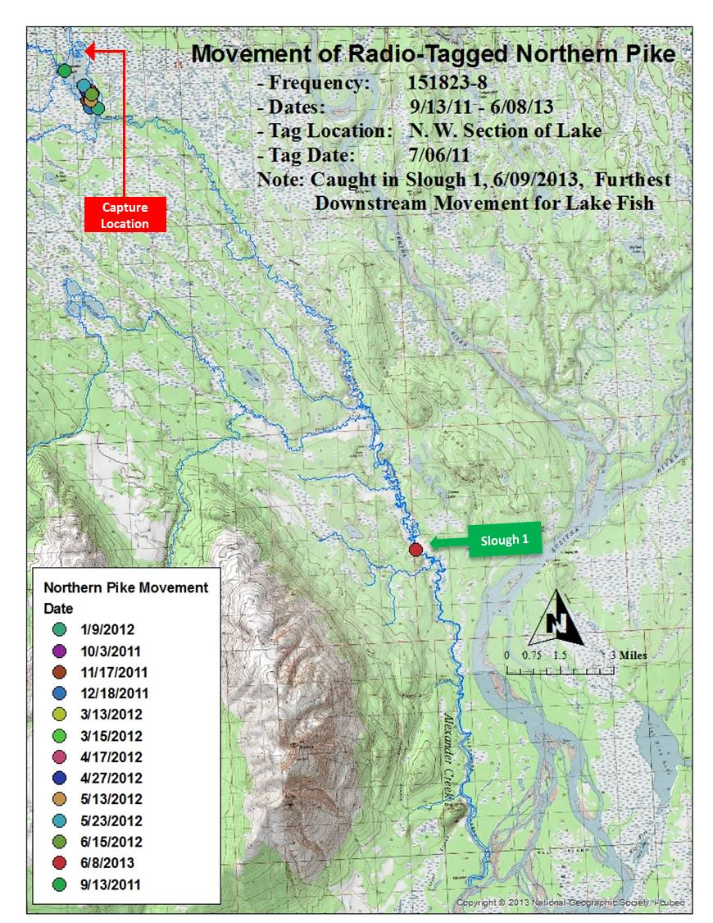

Appendix B2. Movements of lake-tagged northern pike #143 (151.902-19) in the Alexander Creek drainage, June 2012 through early June 2013.

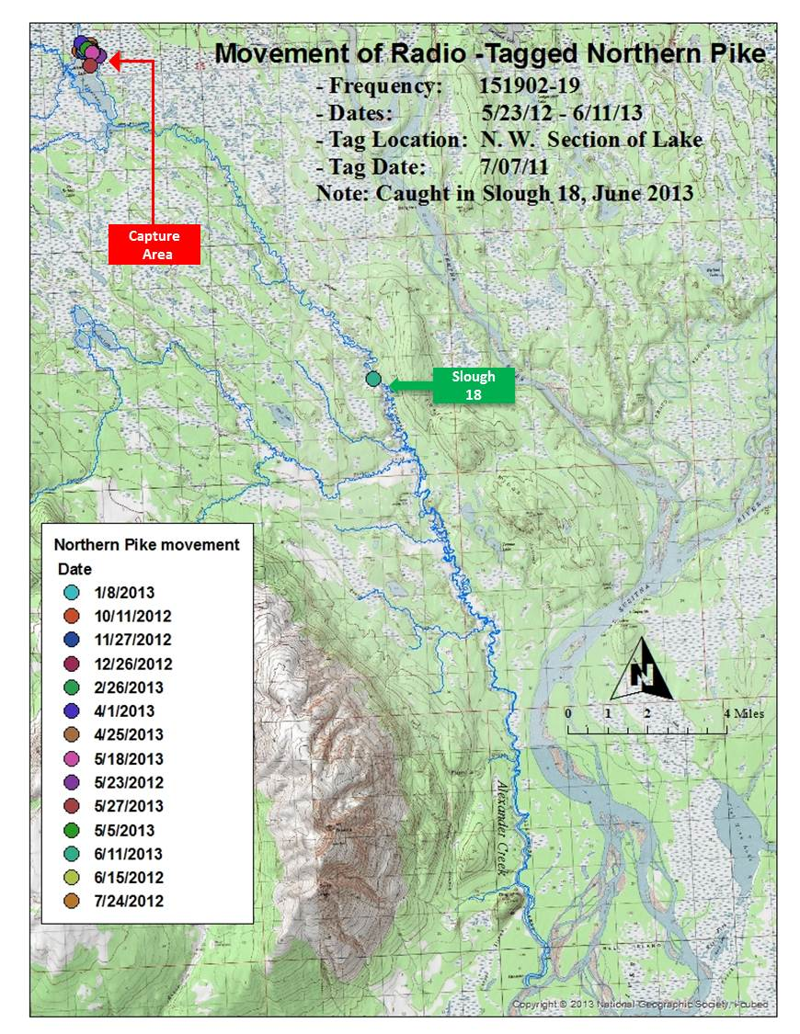

Appendix B3. Movements of lake-tagged northern pike #28 (151.823-2) in the Alexander Creek drainage, August 2011 through May 2012.

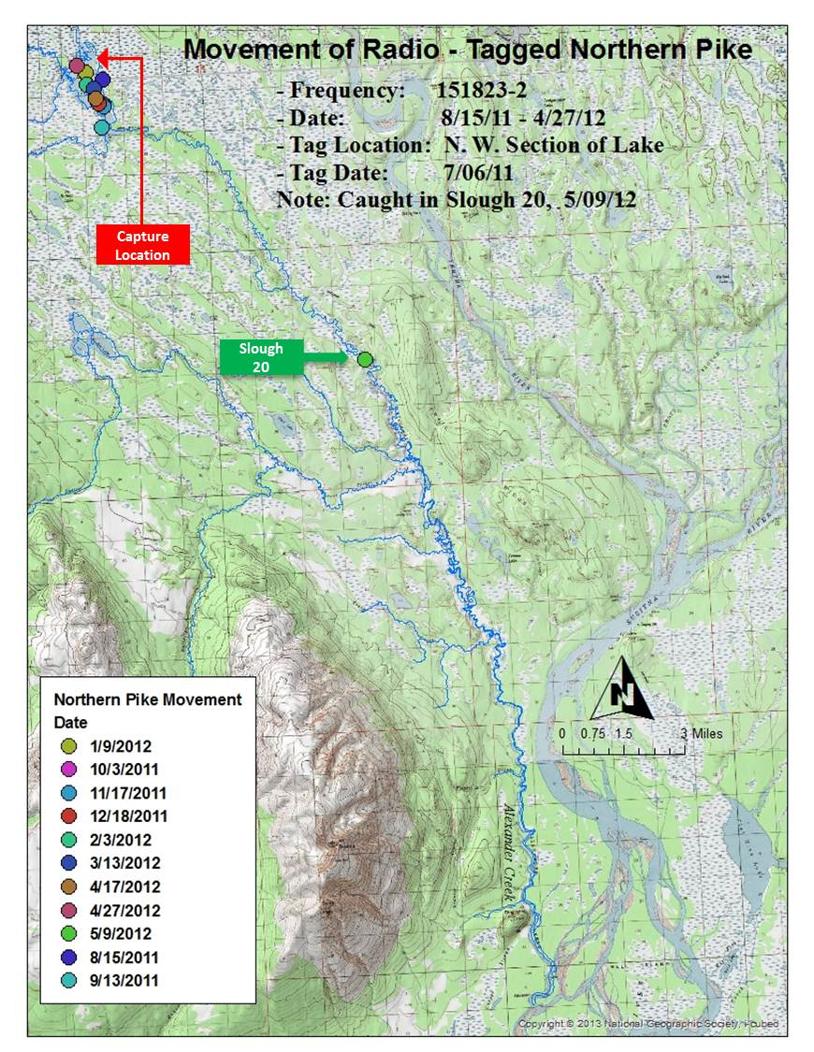

Appendix B4. Movements of lake-tagged northern pike #301(151.823-4) in the Alexander Creek drainage, August 2011 through May 2012.

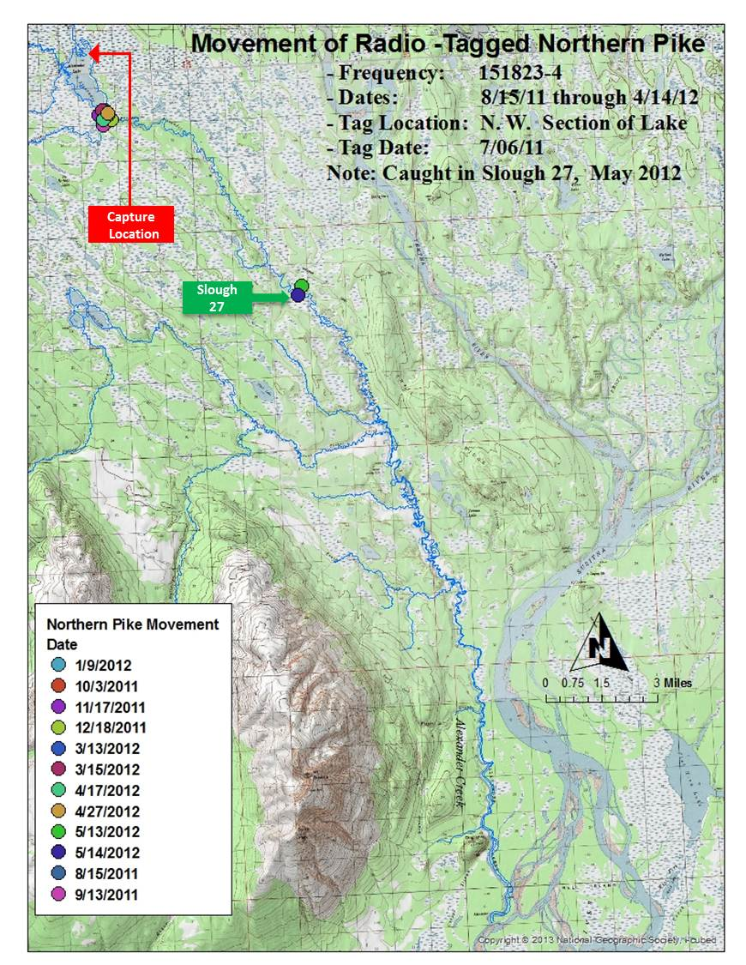

Appendix B5. Movements of lake-tagged northern pike #32 (151.823-6) in the Alexander Creek drainage, September 2011 through May 2012.

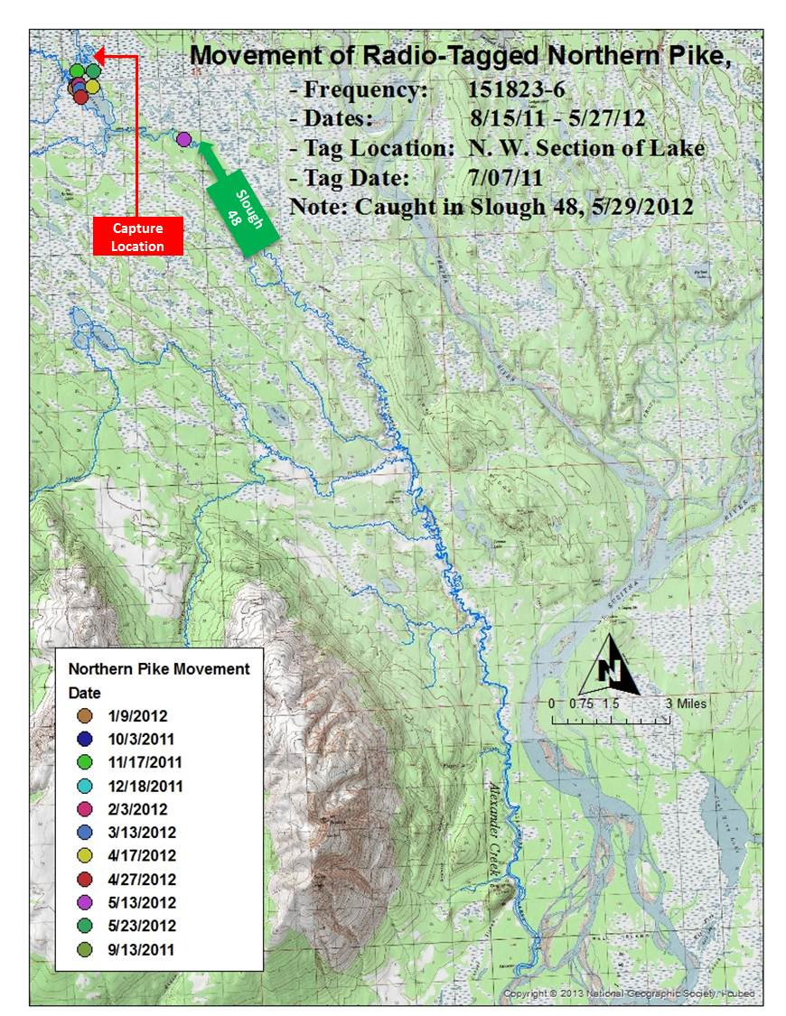

Appendix B6. Movements of lake-tagged northern pike #39 (151.823-15) in the Alexander Creek drainage, Sept 2011 through May 2012.

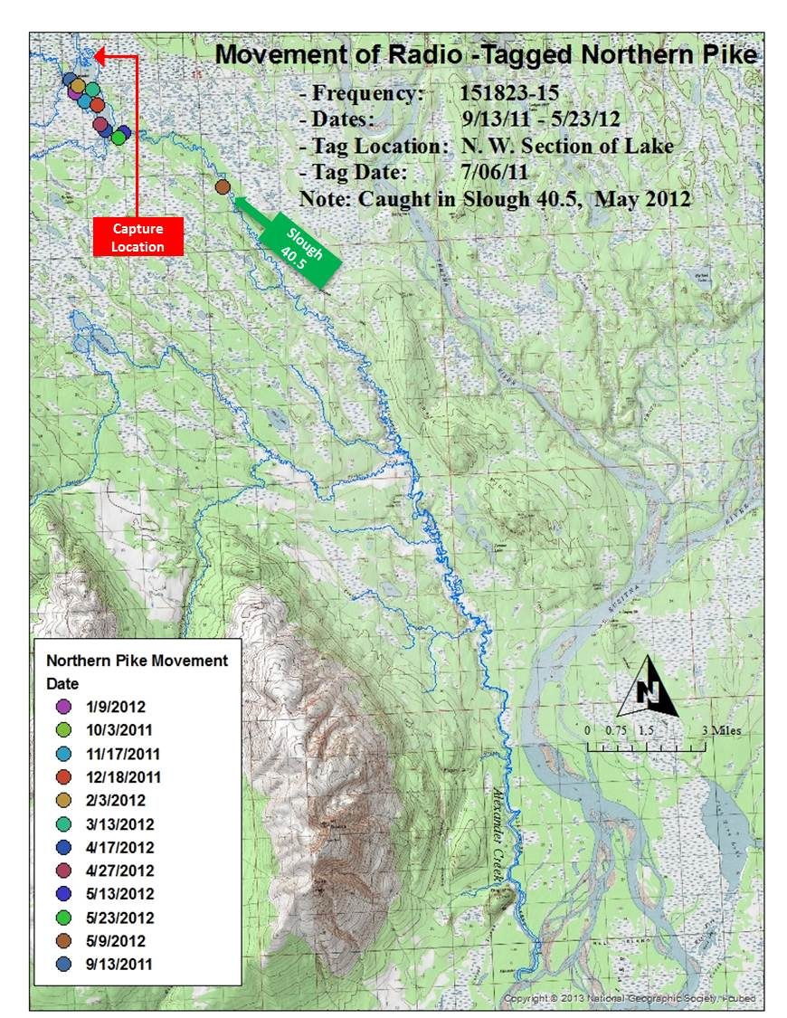

Appendix B7. Movements of lake-tagged northern pike #129 (151.902-3) in the Alexander Creek drainage, August 2011 through May 2012.

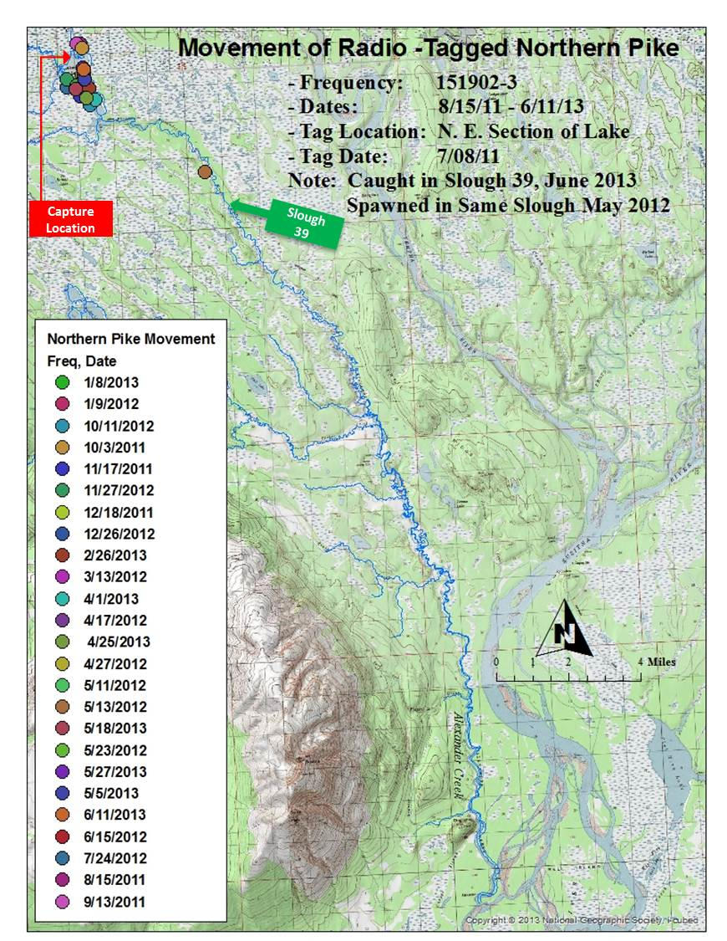

Appendix B8. Movements of lake-tagged northern pike #97 (151.862-23) in the Alexander Creek drainage, August 2011 through June 2013.

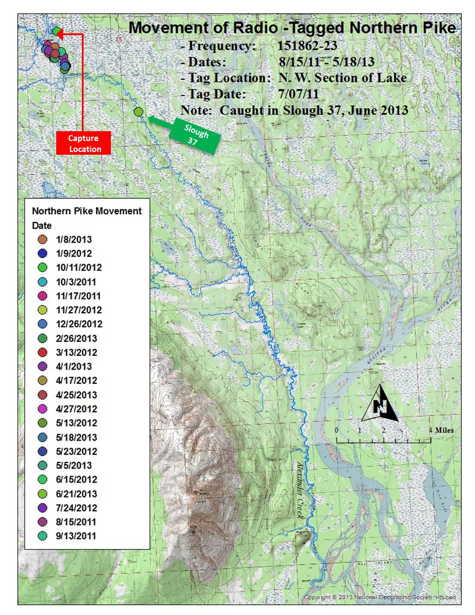

Appendix B9. Movements of lake-tagged northern pike #92 (151.862-19) in the Alexander Creek drainage, August 2011 through June 2013.

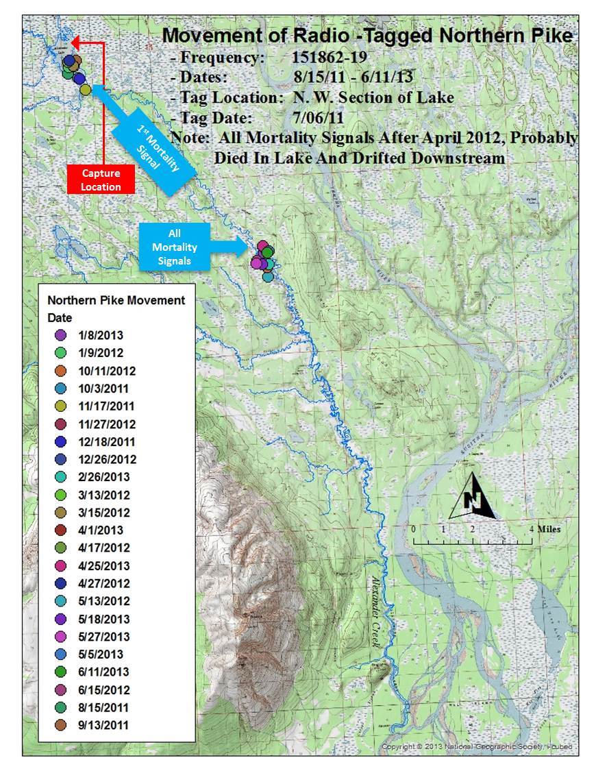

Appendix B10.–Movements of lake-tagged northern pike #40 (151.823-16) in the Alexander Creek drainage, August 2011 through June 2013.

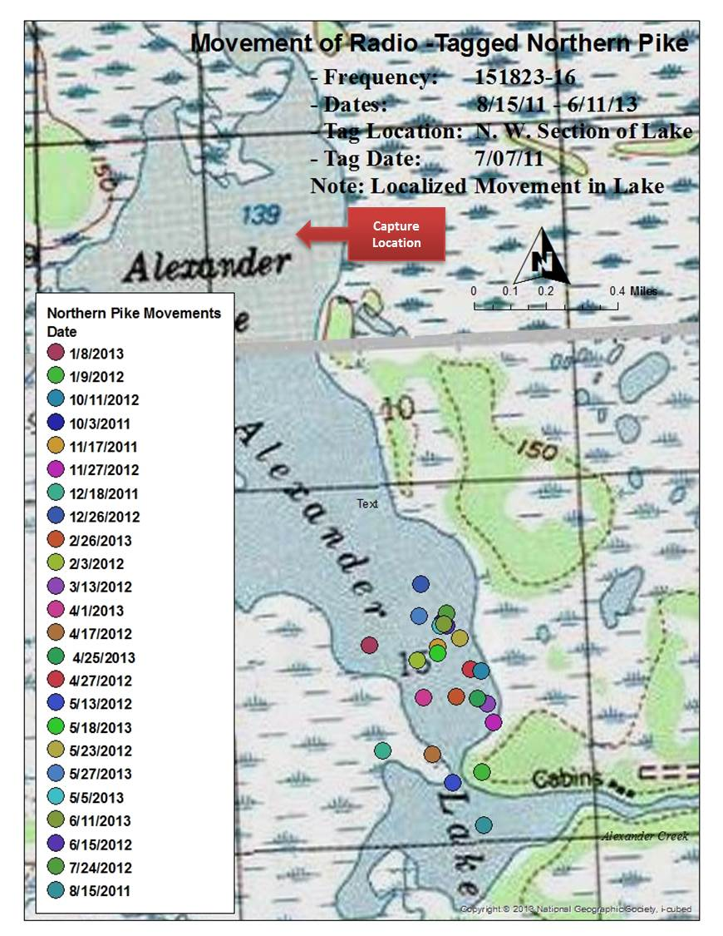

Appendix B11. Movements of lake-tagged northern pike #96 (151.862-22) in the Alexander Creek drainage, September 2011 through June 2013.

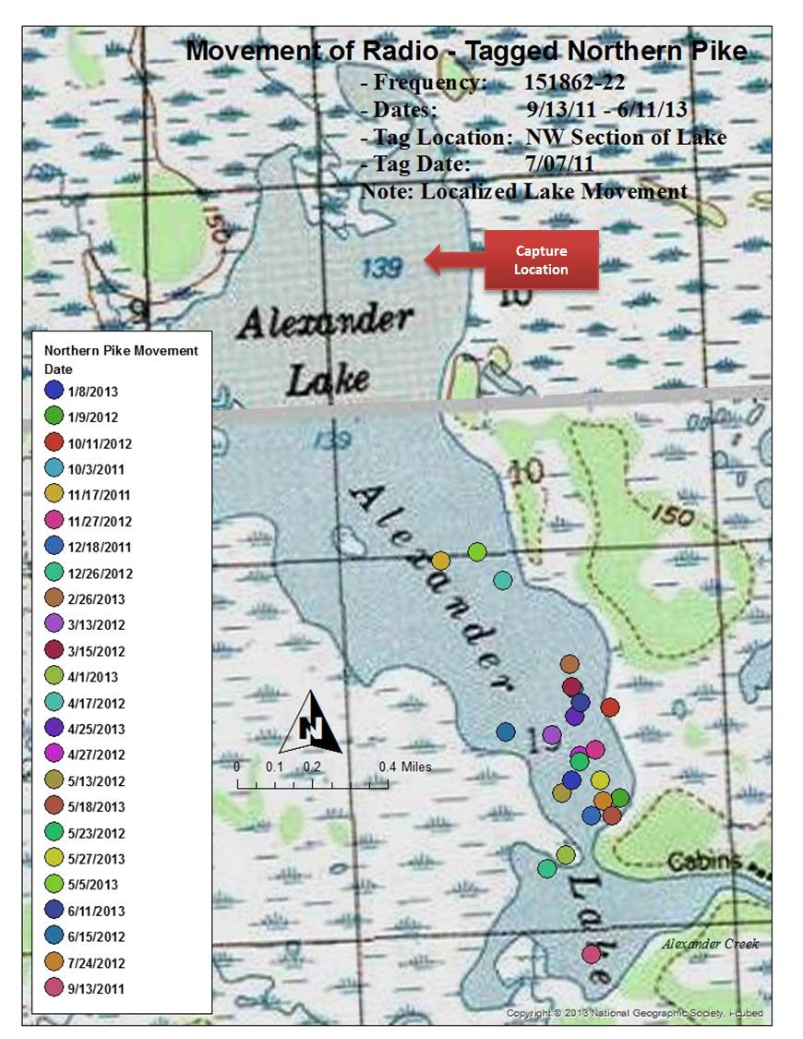

Appendix B12. Movements of lake-tagged northern pike #99 (151.862-26) in the Alexander Creek drainage, August 2011 through June 2013.

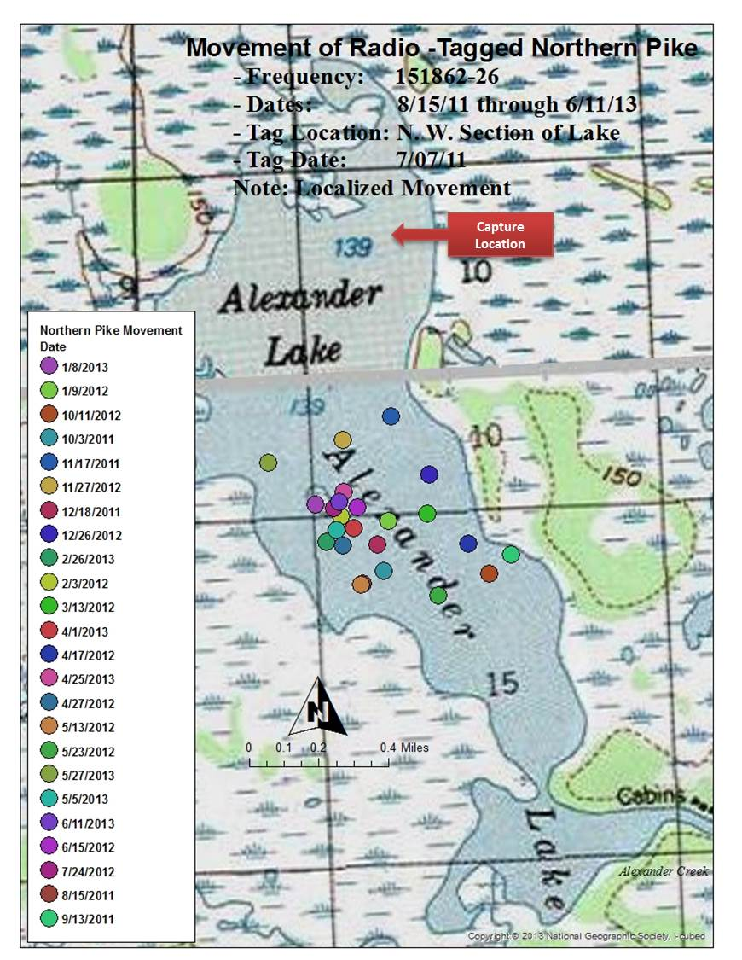

Appendix B13. Movements of lake-tagged northern pike #139 (151.902-14) in the Alexander Creek drainage, September 2011 through June 2013.

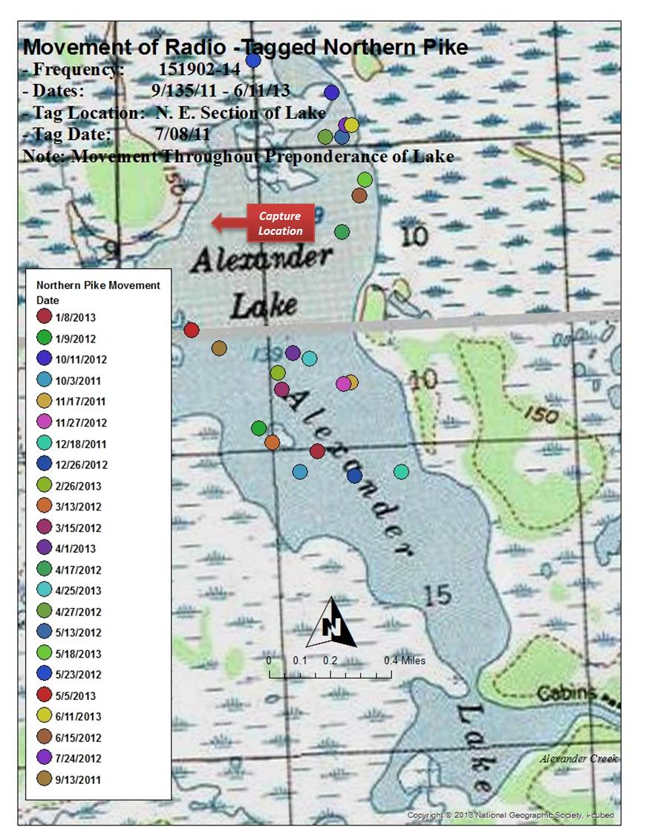

Appendix B14. Movements of lake-tagged northern pike #26 (151.823-0) in the Alexander Creek drainage, September 2011 through June 2013.

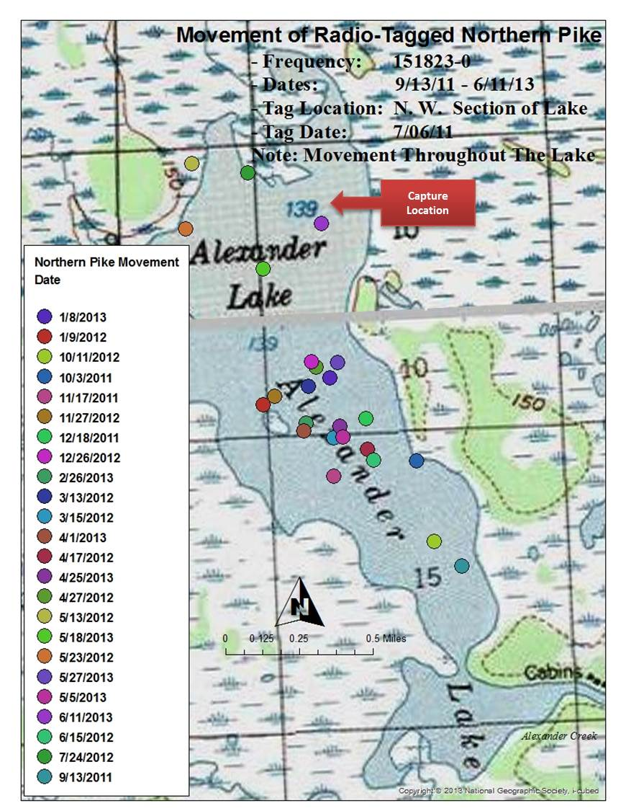

Appendix B15. Movements of lake-tagged northern pike #101 (151.882-0) in the Alexander Creek drainage, August 2011 through June 2013.

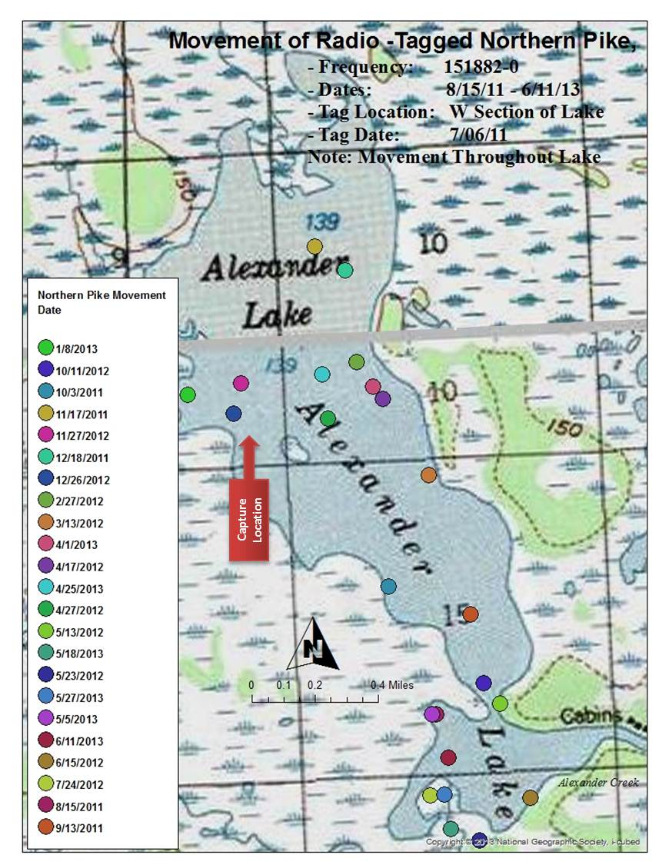

Appendix B16. Movements of creek-tagged northern pike #18 (151.802-19) in the Alexander Creek drainage, August 2011 through May 2013.

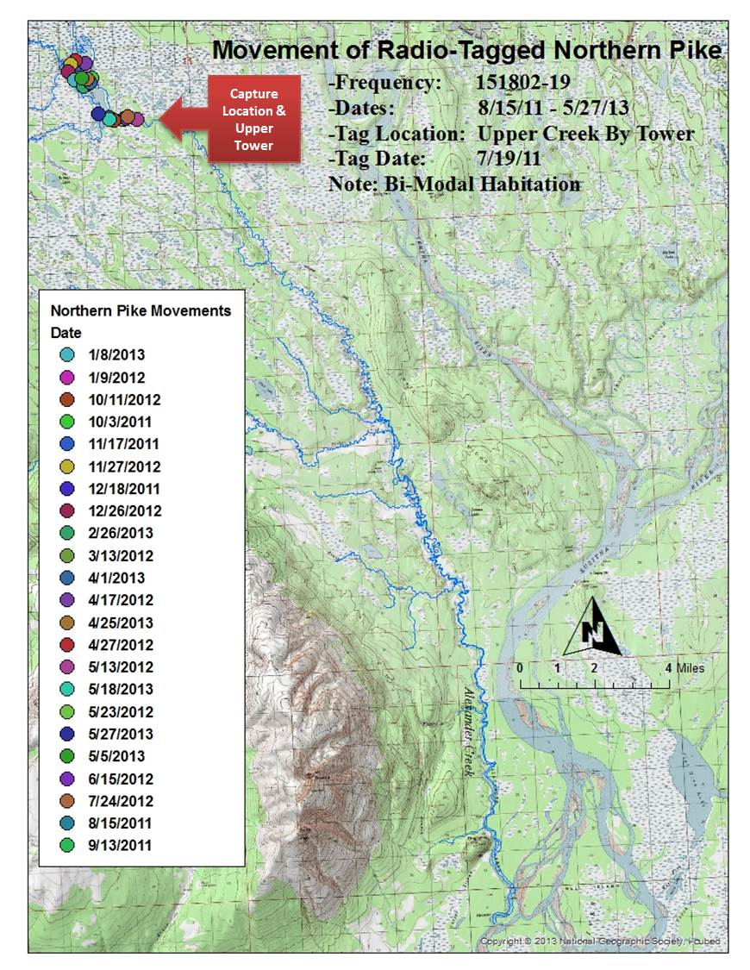

Appendix B17. Movements of creek-tagged northern pike #17 (151.802-06) in the Alexander Creek drainage, September 2011 through May 2012.

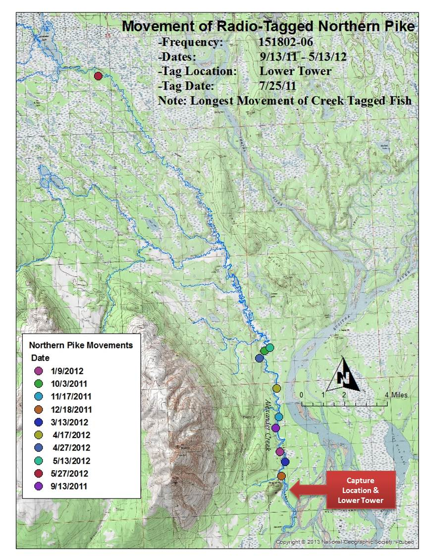

Appendix B18. Movements of creek-tagged northern pike #9 (151.802-09) in the Alexander Creek drainage, August 2011 through June 2013.

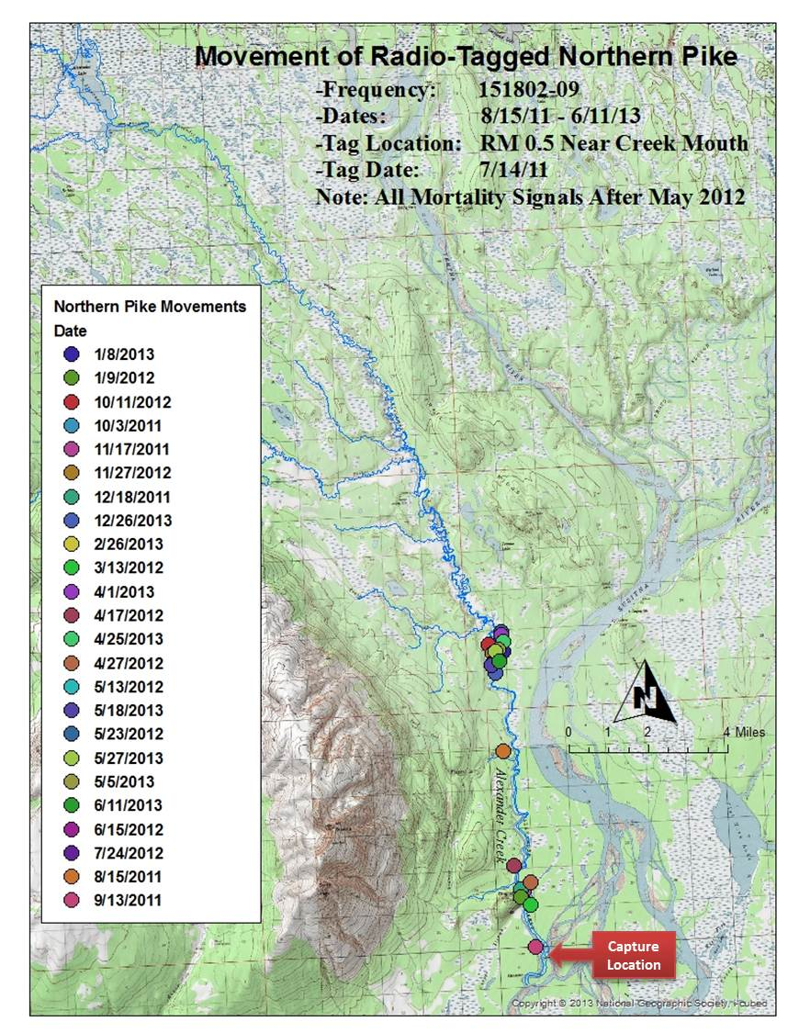

Appendix B19. Movements of creek-tagged northern pike #21 (151.802-22) in the Alexander Creek drainage, August 2011 through April 2012.

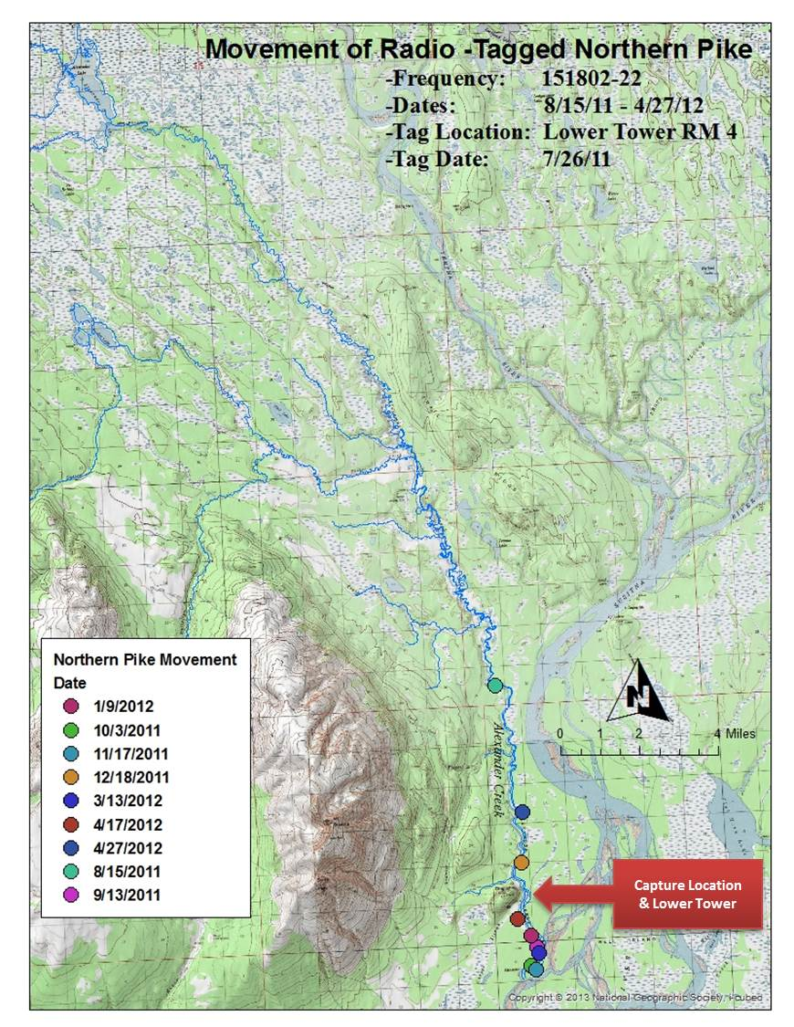

Appendix B20. Movements of creek-tagged northern pike #22 (151.802-23) in the Alexander Creek drainage, August 2011 through May 2012.

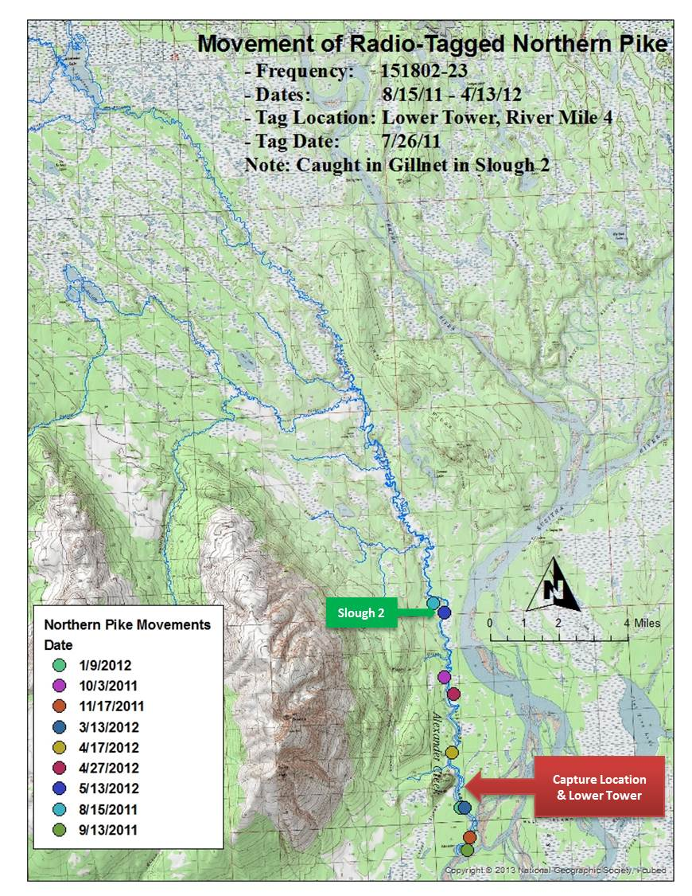

Appendix B21. Movements of lake-caught pike #23 (151.802-24), transferred, tagged and released in lower Alexander Creek, September 2011 through April 2012.

